A Student Proposed Sample Strategic Plan
By Bradley Cooper, MBA
Developed in Dr. Fred David’s
Capstone Strategic Management Course
At Francis Marion University
Spring 2018 Semester

Table of Contents

Vision and Mission Statement Narrative 3
Current Guiding Principles 3
Proposed Vision Statement 3
Proposed Mission Statement 3
Industry Overview 4
Competitor Overview 4
Competitive Profile Matrix (CPM) 4
Ratio Analysis 5
Internal Factor Evaluation (IFE) Matrix 7
External Factor Evaluation (EFE) Matrix 8
Strengths-Weaknesses-Opportunities-Threats (SWOT) Matrix 9
Proposed Strategies Developed from the SWOT Matrix 12
Strategic Position and Action Evaluation (SPACE) Matrix 13
Grand Strategy Matrix 15
Boston Consulting Group (BCG) Matrix 15
Internal - External (IE) Matrix 16
Quantitative Strategic Planning Matrix (QSPM) 17
Organizational Chart 22
Perceptual Maps 22
Firm Valuation 25
Recommendations 26
EPS-EBIT Analysis 27
Projected Financial Statements 28

Vision and Mission Statement Narrative

Netflix does not currently possess an official vision or mission statement. While creating these statements is not necessary for success, they can help to create a cohesive understanding of the company for employees and customers.

The vision statement should be kept simple and goal-oriented, with an emphasis on Netflix’s business identity, quality and quantity of streaming content, and widespread accessibility in multiple countries. The mission statement needs to incorporate the nine core principles, and thus goes into more stringent details to expand on the vision statement. Many of these core principles are found in current guiding principles, only needing to be rearranged into the mission statement. However, no current guiding principle discusses any social responsibility on Netflix’s part. Instead, Netflix has released a press statement concerning their efforts to use sustainable energy which will be used to fulfill this requirement.

Current Guiding Principles

“Becoming the best global entertainment distribution service. Licensing entertainment content around the world. Creating markets that are accessible to film makers. Helping content creators around the world to find a global audience.”
--Reed Hastings, Co-owner and CEO of Netflix, October 2011

“We promise our customers stellar service, our suppliers a valuable partner, our investors the prospects of sustained profitable growth, and our employees the allure of huge impact.”
--Netflix Brand Promise

“To grow our streaming membership business globally within the parameters of our profit margin targets. We are continuously improving our members' experience by expanding our streaming content with a focus on a programming mix of content that delights our members. In addition, we are perpetually enhancing our user interface and extending our streaming service to more internet-connected screens.”
--Netflix Core Strategy

Proposed Vision Statement

“To become the best global distributor of streaming entertainment content with diverse, high quality programming that is widely accessible to members, content creators, and partners.”

Proposed Mission Statement

“Netflix strives to be better entertainment (2, 7) at lower cost (5, 7) and greater scale (4) than the world (3) has ever seen. Our goal is to provide licensed and original entertainment (2) for all ages (1) that can be enjoyed on any internet-connected screen. (4) We promise our members stellar service (6), our suppliers a valuable partner (7), our investors the prospects of sustained profitable growth (5), and our employees the allure of huge impact. (9) We are committed to eco-friendly practices (8) and providing the highest quality content (2, 5) to our valued members. (6)”

- Customers (6) Philosophy
- Products or services (7) Self-Concept
- Markets (8) Public Image
- Technology (9) Employees
- Survival, growth and profitability [Word Count: 98]

Industry Overview

Streaming entertainment content continues to be on the rise while traditional cable TV slowly declines. Subscribers to an online streaming video service in the United States has increased from 51% in 2016 to 58% in 2017. Meanwhile, subscribers to traditional TV services has been in decline since 2012, with the most recent year dropping by 4%. Streaming content is also the primary source of watching TV by 61% of young adults aged 18-29, compared to 31% for cable TV. These numbers drop significantly as age increases due to the adoption of technology, resulting in a total 59% of U.S. adults aged 18+ watching cable TV as their primary source compared to 28% for online streaming services. Additionally, men (31% vs 25%) and college-educated viewers (35% vs 22%) have an increased chance of reporting online streaming as their primary source of TV over their counterparts. The United States has also seen an increase of 8%, or 53 million, internet users from 2016 to 2017, with a global increase of 10%, or 354 million, during the same period.

Competitor Overview

The majority of Netflix’s competitors within the streaming entertainment distribution industry are owned and operated by a parent company, and thus financial information relating to their streaming services are ambiguously consolidated within the parent’s financial statements. This list include: YouTube owned by Google (Alphabet), Amazon Prime Videos and Twitch TV owned by Amazon Inc., Hulu owned primarily by Disney, Sling TV and DirecTV Now owned by Direc TV, HBO Go owned by HBO, and various other smaller competitors with less than 5% market share. Information included in this report for competitors is using best guess estimates provided by the industry.

Competitive Profile Matrix (CPM)
 |  | Netflix |  | Prime Video  (Amazon) |  | Hulu  (Disney)
Critical Success Factors | Weight | Rating | Score | Rating | Score | Rating | Score
1 - Licensed Content | 0.15 | 3 | 0.45 | 2 | 0.30 | 4 | 0.60
2 - Original Content | 0.14 | 4 | 056 | 3 | 0.42 | 2 | 0.28
3 - Market Share | 0.12 | 4 | 0.48 | 3 | 0.36 | 2 | 0.24
4 - Price Competitiveness | 0.12 | 3 | 0.36 | 2 | 0.24 | 4 | 0.48
5 - Service Variety | 0.11 | 1 | 0.11 | 4 | 0.44 | 2 | 0.22
6 - Global Expansion | 0.10 | 4 | 0.40 | 3 | 0.30 | 1 | 0.10
7 - R&D Technology | 0.08 | 3 | 0.24 | 2 | 0.16 | 1 | 0.08
8 - Financial Position | 0.08 | 3 | 0.24 | 4 | 0.32 | 2 | 0.16
9 - Brand Recognition | 0.06 | 4 | 0.24 | 3 | 0.18 | 2 | 0.12
10 - Social Responsibility | 0.04 | 1 | 0.04 | 4 | 0.16 | 2 | 0.08
TOTAL | 1.00 |  | 3.12 |  | 2.88 |  | 2.36

Ratio Analysis
Of the nine financial ratios and indicators evaluated, Netflix ranks best in four of the categories for 2017. Notably, Netflix has had a stellar Net Income Growth for 2017. However, the scale of the growth is much less significant than either Amazon or Disney, being measured in millions rather than billions, leading to a miniscule Earnings per Share. The other worst ratio for Netflix in 2017 is a Debt-to-Equity ratio 15% worse than the next competitor, Amazon. Netflix will need to reevaluate its capital structure, lowering debt and increasing equity, in order to improve its financial health.
Current Ratio | 2013 | 2014 | 2015 | 2016 | 2017
Netflix | 1.420 | 1.475 | 1.539 | 1.247 | 1.403
Amazon | 1.072 | 1.115 | 1.054 | 1.045 | 1.040
Disney | 1.205 | 1.142 | 1.026 | 1.007 | 0.811

Quick Ratio | 2013 | 2014 | 2015 | 2016 | 2017
Netflix | 1.420 | 1.475 | 1.539 | 1.247 | 1.403
Amazon | 0.749 | 0.820 | 0.751 | 0.783 | 0.763
Disney | 1.078 | 1.023 | 0.930 | 0.925 | 0.741

Debt-to-Equity Ratio | 2013 | 2014 | 2015 | 2016 | 2017
Netflix | 3.059 | 2.791 | 3.589 | 4.070 | 4.308
Amazon | 3.121 | 4.074 | 3.838 | 3.325 | 3.739
Disney | 0.687 | 0.747 | 0.812 | 0.945 | 1.128
*For Debt-to-Equity, lower values are considered better for the organization’s financial health

Asset Turnover | 2013 | 2014 | 2015 | 2016 | 2017
Netflix | 0.808 | 0.782 | 0.664 | 0.650 | 0.615
Amazon | 1.854 | 1.633 | 1.653 | 1.631 | 1.355
Disney | 0.554 | 0.580 | 0.595 | 0.604 | 0.576

Net Profit Margin | 2013 | 2014 | 2015 | 2016 | 2017
Netflix | 0.026 | 0.048 | 0.018 | 0.021 | 0.048
Amazon | 0.004 | -0.003 | 0.006 | 0.017 | 0.017
Disney | 0.136 | 0.154 | 0.160 | 0.169 | 0.163

Return on Assets | 2013 | 2014 | 2015 | 2016 | 2017
Netflix | 0.021 | 0.038 | 0.012 | 0.014 | 0.029
Amazon | 0.007 | -0.004 | 0.009 | 0.028 | 0.023
Disney | 0.076 | 0.089 | 0.095 | 0.102 | 0.094

Return on Equity | 2013 | 2014 | 2015 | 2016 | 2017
Netflix | 0.084 | 0.144 | 0.055 | 0.070 | 0.156
Amazon | 0.028 | -0.022 | 0.045 | 0.123 | 0.109
Disney | 0.127 | 0.156 | 0.172 | 0.198 | 0.200

Earnings per Share | 2013 | 2014 | 2015 | 2016 | 2017
Netflix | 0.28 | 0.63 | 0.29 | 0.44 | 1.29
Amazon | 0.60 | 0.52 | 1.28 | 5.01 | 6.32
Disney | 4.31 | 3.42 | 4.95 | 5.76 | 5.73

Net Income Growth | 2013 | 2014 | 2015 | 2016 | 2017
Netflix | 6.553 | 2.374 | 0.460 | 1.522 | 2.994
Amazon | -8.026 | -1.880 | -3.473 | 2.978 | 0.279
Disney | 1.165 | 1.222 | 1.117 | 1.120 | 0.956
*Amazon has three negative Net Income Growths due to a loss of Net Income in 2012 and 2014

Internal Factor Evaluation (IFE) Matrix
 | Key Internal Strengths | Weight | Rating | Score
1 | Revenues increased 32% from 2017 to 2018, resulting in a 121% increase in operating income and 199% increase in net income | 0.12 | 3 | 0.36
2 | For the first time ever, generated a contribution profit from international membership ($226 million) and its international membership surpassed domestic membership by 15% | 0.09 | 4 | 0.36
3 | Gained 25% more subscribers in both 2016 and 2017, broken down to 22% domestic and 109% international | 0.09 | 4 | 0.36
4 | Increased spending on its licensed content library by 23% from 2016 to 2017, now totalling over 140 million hours of content | 0.04 | 3 | 0.12
5 | Grew to 5,500 total employees in 2017, up 800 from 2016, and is ranked #9 for 2017 Best Company Culture | 0.04 | 3 | 0.12
6 | Increased technology and development costs by 62% since 2015, with a push to access more internet-connected screens, tap into the smart home market, and utilize the latest 4K graphics | 0.04 | 4 | 0.16
7 | Offers three different streaming membership levels to suit customer needs, ranging from $7.99/mo to $13.99/mo | 0.03 | 4 | 0.12
8 | Unlike competitors, has been able to sustain profits without needing to provide advertisements during streaming. Customers appreciate this when deciding on a service | 0.02 | 3 | 0.06
9 | Strong seasonality that coincides with purchases of electronic devices, typically in Q4 and Q1 | 0.02 | 3 | 0.06
10 | Published its own internet speed testing website, fast.com, so customers can see what speed their internet service providers are allowing for Netflix. This combats attempts against net neutrality and provides more brand awareness | 0.01 | 3 | 0.03
 | Key Internal Weaknesses
1 | Majority of content is licensed from others, and negotiations have the potential to fall through, be withdrawn, or changed | 0.12 | 2 | 0.24
2 | Strongly dependent on internet service providers and electronic manufacturers for providing access to Netflix | 0.08 | 1 | 0.08
3 | Must create original content, which is more costly to produce than licensing, in order to distinguish itself from competitors | 0.06 | 2 | 0.12
4 | Net DVD assets halved from 2016 ($25 million) to 2017 ($13 million) while DVD memberships decreased by 18%. Still currently provides a 55% contribution profit, but is decreasing | 0.05 | 1 | 0.05
5 | Many competitors are services provided as part of a parent organization that have access to other revenue streams | 0.05 | 1 | 0.05
6 | Debt-to-equity ratio has been steadily increasing, with 3.59 in 2015, 4.07 in 2016, and 4.31 in 2017 (20% increase from 2015) | 0.04 | 2 | 0.08
7 | Strong push for international expansion is only beginning to pay off with a 4% contribution after years of losses, while domestic streaming has a 37% profit margin and less marketing costs | 0.03 | 2 | 0.06
8 | Despite young adults and college-educated adults having increased likelihood to subscribe, Netflix does not offer any special benefits to target this key demographic | 0.03 | 1 | 0.03
9 | Allowing members to stream on multiple screens simultaneously, combined with account sharing, reduces subscriber revenue | 0.03 | 2 | 0.06
10 | Loose control over third-party contractors needed to stream content has lead to a poor (“D”) rating in environmentalism | 0.01 | 1 | 0.01
 | TOTAL | 1.00 |  | 2.53

External Factor Evaluation (EFE) Matrix
 | Key External Opportunities | Weight | Rating | Score
1 | Another 33% of United States consumers switched away from traditional TV in search of alternatives in 2017 | 0.12 | 4 | 0.48
2 | Global number of consumers with access to the internet has increased by 8% in the past year | 0.10 | 3 | 0.30
3 | In 2017, 73% of Americans surveyed admitted to having “binge-watched” one or more shows for over 5 hours. Over 90% of millennials had binge-watched, and 38% did so every week | 0.07 | 4 | 0.28
4 | Smart TVs in the United States rose from 46.9% penetration in 2015 to 56.1% in 2016; expected to raise to 60.4% in 2020 | 0.05 | 4 | 0.20
5 | Global economic growth expected to rise from 3.0% in 2017 to 3.1% in 2018, and then decrease back to 3.0% in 2019. | 0.04 | 3 | 0.12
6 | Average household annual incomes in the United States has increased 7% since 2014 | 0.04 | 2 | 0.08
7 | Hulu raised over $1 billion (~50%) of its revenue in 2017 from advertisements, while cable TV earned $71.3 billion (41%) in 2016 | 0.04 | 1 | 0.04
8 | Percentage of college-educated or enrolled adults in the United States has increased steadily since 1970, increasing 1.1% and 0.7% from 2015 to 2016, respectively | 0.02 | 1 | 0.02
9 | Renewable energy costs are quickly falling, notably solar power by 73% in 2017, and expected to overtake fossil fuels by 2020 | 0.01 | 2 | 0.02
10 | Number of global mobile phone or tablet users has increased by 19% from 2013 to 2017 | 0.01 | 4 | 0.04
 | Key External Threats
1 | Pirating is expected to cost Netflix and other streaming services $50 billion in revenue between 2016 and 2022. | 0.10 | 3 | 0.30
2 | Disney plans to launch a streaming service in 2019 to directly compete with Netflix and plans to remove content from Netflix at the end of 2018. They also recently purchased 21st Century Fox to acquire new content and majority ownership of Hulu. | 0.10 | 2 | 0.20
3 | Red Box released a new streaming service in December 2017 to allow customers to “rent” digital content for a limited time period for $1.99 per title, no subscriptions required | 0.08 | 2 | 0.16
4 | China, with an expected 1.03 billion internet connected users in 2018, does not permit Netflix to be streamed in the country | 0.06 | 3 | 0.18
5 | Net neutrality repeal in the United States may force Netflix or its customers to pay Internet Service Providers increased fees for faster access. This happened previously in 2014 for an undisclosed amount that increased speeds by 65% | 0.04 | 4 | 0.16
6 | Average cost to produce an hour of original TV content has increased over 300% since 2012 | 0.04 | 1 | 0.04
7 | YouTube and Twitch TV, each service taking up 35% of the non-Netflix audience for online streaming, are based on home user content with minimal production cost for the company | 0.03 | 1 | 0.03
8 | Other competitors, like Hulu and Sling TV, offer live or day-after TV episode viewing, rather than waiting for the season to be over | 0.02 | 2 | 0.04
9 | Home DVR devices, which allows for limited video-on-demand service for traditional TV programming, have increased from 44% of home consumers in 2011 to 53% in 2017 | 0.02 | 3 | 0.06
10 | United States box office sales dropped 1.6% from 2015 to 2017 and DVD sales dropped 18% in the United States in 2017 | 0.01 | 4 | 0.04
 | TOTAL | 1.00 |  | 2.79

Strengths-Weaknesses-Opportunities-Threats (SWOT) Matrix
 | Strengths
1 | Revenues increased 32% from 2017 to 2018, resulting in a 121% increase in operating income and 199% increase in net income
2 | For the first time ever, generated a contribution profit from international membership ($226 million) and its international membership surpassed domestic membership by 15%
3 | Gained 25% more subscribers in both 2016 and 2017, broken down to 22% domestic and 109% international
4 | Increased spending on its licensed content library by 23% from 2016 to 2017, now totalling over 140 million hours of content
5 | Grew to 5,500 total employees in 2017, up 800 from 2016, and is ranked #9 for 2017 Best Company Culture
6 | Increased technology and development costs by 62% since 2015, with a push to access more internet-connected screens, tap into the smart home market, and utilize the latest 4K graphics
7 | Offers three different streaming membership levels to suit customer needs, ranging from $7.99/mo to $13.99/mo
8 | Unlike competitors, has been able to sustain profits without needing to provide advertisements during streaming. Customers appreciate this when deciding on a service
9 | Strong seasonality that coincides with purchases of electronic devices, typically in Q4 and Q1
10 | Published its own internet speed testing website, fast.com, so customers can see what speed their internet service providers are allowing for Netflix. This combats attempts against net neutrality and provides more brand awareness

 | Weaknesses
1 | Majority of content is licensed from others, and negotiations have the potential to fall through, be withdrawn, or changed
2 | Strongly dependent on internet service providers and electronic manufacturers for providing access to Netflix
3 | Must create original content, which is more costly to produce than licensing, in order to distinguish itself from competitors
4 | Net DVD assets halved from 2016 ($25 million) to 2017 ($13 million) while DVD memberships decreased by 18%. Still currently provides a 55% contribution profit, but is decreasing
5 | Many competitors are services provided as part of a parent organization that have access to other revenue streams
6 | Debt-to-equity ratio has been steadily increasing, with 3.59 in 2015, 4.07 in 2016, and 4.31 in 2017 (20% increase from 2015)
7 | Strong push for international expansion is only beginning to pay off with a 4% contribution after years of losses, while domestic streaming has a 37% profit margin and less marketing costs
8 | Despite young adults and college-educated adults having increased likelihood to subscribe, Netflix does not offer any special benefits to target this key demographic
9 | Allowing members to stream on multiple screens simultaneously, combined with account sharing, reduces subscriber revenue
10 | Loose control over third-party contractors needed to stream content has lead to a poor (“D”) rating in environmentalism

 | Opportunities
1 | Another 33% of United States consumers switched away from traditional TV in search of alternatives in 2017
2 | Global number of consumers with access to the internet has increased by 8% in the past year
3 | In 2017, 73% of Americans surveyed admitted to having “binge-watched” one or more shows for over 5 hours. Over 90% of millennials had binge-watched, and 38% did so every week
4 | Smart TVs in the United States rose from 46.9% penetration in 2015 to 56.1% in 2016; expected to raise to 60.4% in 2020
5 | Global economic growth expected to rise from 3.0% in 2017 to 3.1% in 2018, and then decrease back to 3.0% in 2019.
6 | Average household annual incomes in the United States has increased 7% since 2014
7 | Hulu raised over $1 billion (~50%) of its revenue in 2017 from advertisements, while cable TV earned $71.3 billion (41%) in 2016
8 | Percentage of college-educated or enrolled adults in the United States has increased steadily since 1970, increasing 1.1% and 0.7% from 2015 to 2016, respectively
9 | Renewable energy costs are quickly falling, notably solar power by 73% in 2017, and expected to overtake fossil fuels by 2020
10 | Number of global mobile phone or tablet users has increased by 19% from 2013 to 2017

 | Threats
1 | Pirating is expected to cost Netflix and other streaming services $50 billion in revenue between 2016 and 2022.
2 | Disney plans to launch a streaming service in 2019 to directly compete with Netflix and plans to remove content from Netflix at the end of 2018. They also recently purchased 21st Century Fox to acquire new content and majority ownership of Hulu.
3 | Red Box released a new streaming service in December 2017 to allow customers to “rent” digital content for a limited time period for $1.99 per title, no subscriptions required
4 | China, with an expected 1.03 billion internet connected users in 2018, does not permit Netflix to be streamed in the country
5 | Net neutrality repeal in the United States may force Netflix or its customers to pay Internet Service Providers increased fees for faster access. This happened previously in 2014 for an undisclosed amount that increased speeds by 65%
6 | Average cost to produce an hour of original TV content has increased over 300% since 2012
7 | YouTube and Twitch TV, each service taking up 35% of the non-Netflix audience for online streaming, are based on home user content with minimal production cost for the company
8 | Other competitors, like Hulu and Sling TV, offer live or day-after TV episode viewing, rather than waiting for the season to be over
9 | Home DVR devices, which allows for limited video-on-demand service for traditional TV programming, have increased from 44% of home consumers in 2011 to 53% in 2017
10 | United States box office sales dropped 1.6% from 2015 to 2017 and DVD sales dropped 18% in the United States in 2017

Proposed Strategies Developed from the SWOT Matrix
 | Strength-Opportunity (SO) Strategies
1 | Continue pushing for international membership by increasing spending on international marketing by 40% (S1 - S2 - S3 - O2 - O5)
2 | Prioritize acquiring TV shows that can be binge-watched, averaging 5 hours of content per week or more to satisfy habits of Americans (S4 - O1 - O3)
3 | Offer minimally intrusive advertising, such as banners or images, during the ten second transitions between episodes to generate additional revenue (S4 - S8 - 07)
4 | Offer promotional discounts between Christmas and New Years for customers to experience Netflix on newly purchased devices. This might need to complement the one-month-free promotion for customers who previously took the trial month (S9 - O4 - O10)

 | Weakness-Opportunity (WO) Strategies
1 | Offer an educational discount for $1 off single-device membership with proof of student status (W8 - W9 - O3 - O8)
2 | Commit to sourcing 80% or more of energy consumption to renewable sources by 2023, and negotiate with third party vendors to encourage renewable energy in the supply chain (W10 - O9)
3 | Redirect 20% of domestic market spending to international marketing (W7 - O2 - O5 - O10)
4 | Continue partnering with smart TV and other smart home technology manufacturers to have Netflix available or pre-installed on newly developed products (W2 - O4 - O6 - O10)

 | Strength-Threats (ST) Strategies
1 | Continue opposing the repeal of net neutrality to avoid paying excess fees or losing membership from increased costs (S10 - T5)
2 | Negotiate with Chinese government to offer jobs and resources within China to penetrate the market. Offering Netflix in China, who is ranked #1 in the world for pirated software, may help to reduce pirated content globally (S2 - S3 - S4 - S5 - T1 - T4)
3 | Take customers away from Red Box On Demand by offering small subscription periods (e.g. one or two days) for limited, pre-packaged content (e.g. romantic movies, holiday content, TV series, etc.) for a comparable price of $1.99 or less (S7 - T3)
4 | Increase spending on Technology and Development by 30% to stay current with technology trends, possibly exploring virtual reality and interactive content (S6 - T2 - T3 - T7)

 | Weakness-Threats (WT) Strategies
1 | Diversifying services will provide additional sources of revenue. Netflix could investigate partnering with other companies or create its own service to merchandise official items from its original content (W1 - W5 - T2 - T3 - T6 - T7)
2 | Continue shifting away from DVDs, reducing net DVD inventory by 25% in 2018, in favor of acquiring licensed content or producing original content (W4 - T10)
3 | Finding new sources of licensed content exclusive to Netflix will ease pressure from competitive streaming services. Netflix could expand on original content by opening a contest for amateur content creators to pitch their show ideas (W1 - W3 - T2 - T3 - T7)
4 | Create streaming “channels” running 24/7 to emulate traditional TV broadcasting. This can begin by mixing current content sectioned by genre, and can later expand to sports and/or gaming content that is popular with young adults (W1 - W3 - W4 - W8 - T7 - T8 - T9)

Strategic Position and Action Evaluation (SPACE) Matrix

Netflix currently exists within the aggressive quadrant of the SPACE matrix thanks to a 200% increase in Net Income, strong international growth, and unrivaled market share. To capitalize on this advantage, Netflix must take this opportunity to expand its product line with original content, increase spending on international marketing, and consider purchasing or starting other business ventures within the entertainment industry.

Meanwhile, competitor Hulu is slowly expanding its range of services while enjoying a slow increase in market share, and Prime Video is building revenue for expansion. However, only the financial position of the streaming services are considered, ignoring any non-streaming services provided by the parent companies. In reality, Hulu and Prime Video have access to many alternative sources of revenue through Disney and Amazon, respectively, that allow both companies to afford taking greater risks when ramping up their content, if so desired. Additionally, Netflix faces increasing competition as the market becomes easier to enter. Netflix can expect to maintain its hold in the domestic market, but must act quickly to secure international footing.
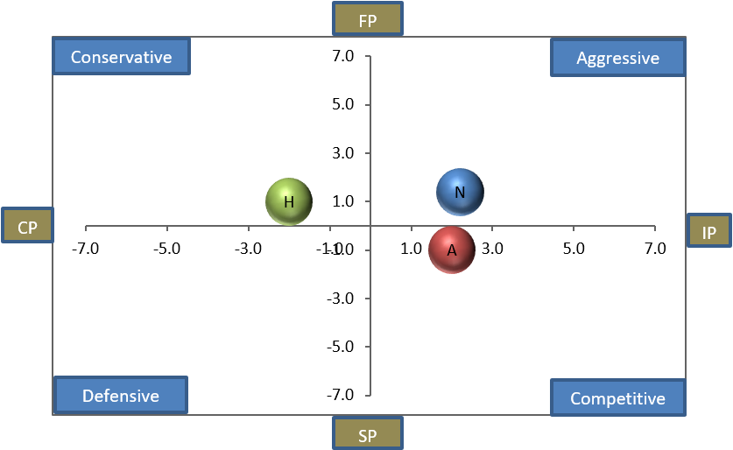

Netflix (N)  X-Axis: 2.2  Y-Axis: 1.4 | 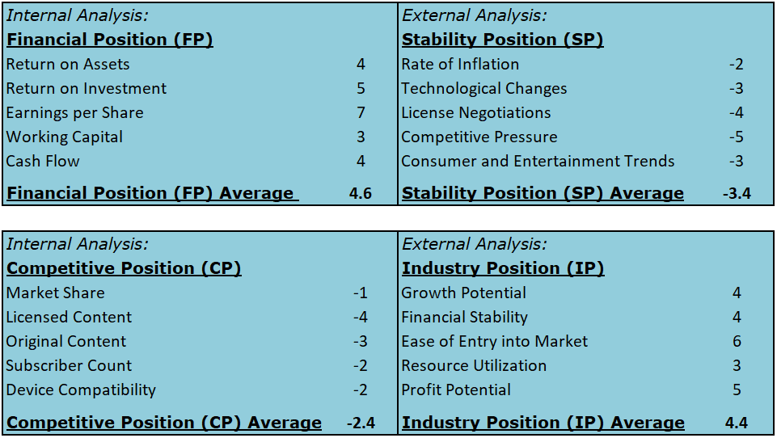
Amazon (A)
X-Axis: 2.0
Y-Axis: -1.0

Hulu (H)
X-Axis: -2.0
Y-Axis: 1.0

Grand Strategy Matrix

The international streaming market is showing a very rapid growth, nearly quadrupling the growth experienced by the domestic streaming market. Being placed in quadrant II, this means Netflix should continue its penetration into the market against established, foreign competitors. Conversely, domestic streaming is enjoying a stable, albeit slow, increase in growth in quadrant I. Netflix should maintain its current dominance with the continuous introduction of new content for consumers. Lastly, the domestic DVD market is slowly declining, and Netflix should reduce the purchase of DVD assets, divest revenues to international streaming, and slowly liquidate the segment throughout its natural decline.

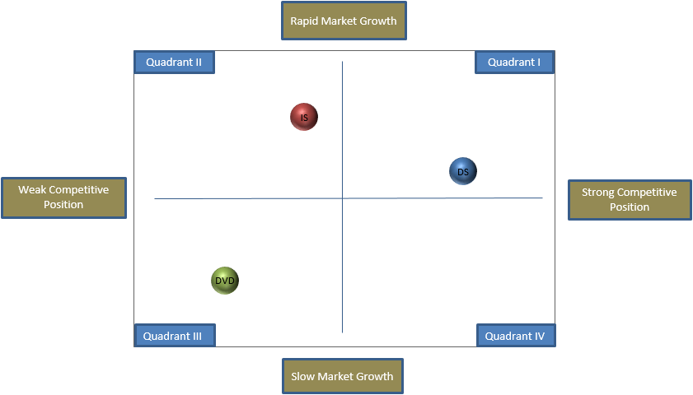
Domestic Streaming (DS)  X-Axis: 8.0  Y-Axis: 6.0 | International Streaming (IS)  X-Axis: 4.0  Y-Axis: 8.0 | Domestic DVD (DVD)  X-Axis: 2.0  Y-Axis: 2.0

Boston Consulting Group (BCG) Matrix

Due to the rapid growth of the streaming segment and rapid decline of the DVD segments, the Y-Axis of the BCG Matrix has been scaled up by a factor of 3. For competitors, Amazon and Hulu were chosen to determine the streaming market growth rate domestically and internationally. For the DVD segment, Redbox revenues were chosen as the market share leader in the DVD rental market. In all cases, Netflix was found to have the highest revenues from the services when compared to its competitors.

International streaming and domestic streaming are the stars of Netflix’s revenue, with domestic streaming having higher revenue and international streaming having higher growth rate. Both should be investment priorities for Netflix, although a bigger emphasis should be placed on the international streaming for its higher growth rate. The domestic DVD segment is currently a cash cow in decline, and should have most of its revenues diverted to international growth throughout its natural decline.
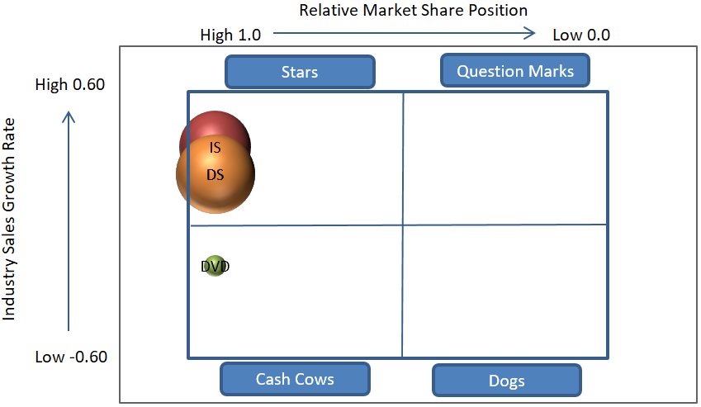

Division | Netflix Revenue | Top Revenue | Market Growth Rate | RMSP
Domestic Streaming (DS) | $6,153,000.00 | $6,153,000.00 | 0.51 | 1.00
International Streaming (IS) | $5,089,000.00 | $5,089,000.00 | 0.32 | 1.00
Domestic DVD (DVD) | $450,000.00 | $450,000.00 | -0.28 | 1.00

Internal - External (IE) Matrix

The IE Matrix is performed using 2017 subscription memberships rather than revenues to examine a different source of information than the BCG Matrix. In doing so, it is evident to see that the international streaming membership count is higher than the domestic streaming membership count despite bringing in less revenues. As a result, Netflix should utilize more of its internal advantages, such as the 200% increase in net income, to capitalize on the external advantages for adoption of Netflix internationally. Otherwise, the weak external factors surrounding domestic streaming can be expected to improve as brand awareness and technological changes pushes more cable-cutters to search for alternative sources of entertainment. The DVD segment, as has been stated multiple time, should have its revenue diverted to fund international or domestic streaming throughout the remainder of its natural decline.
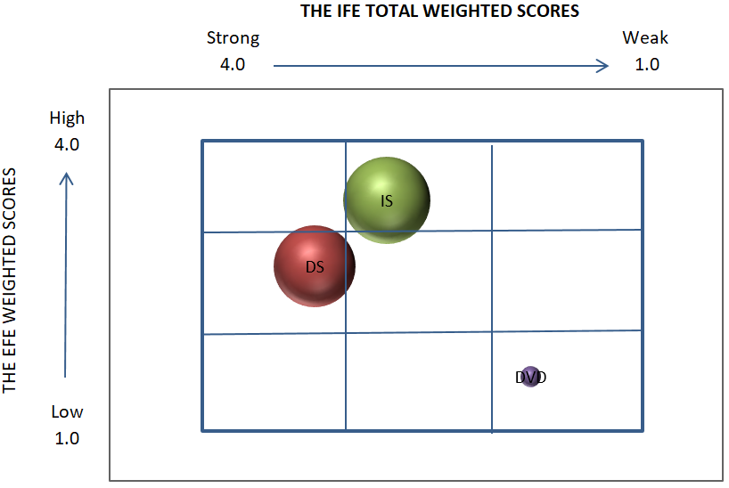

Division | Subscriptions | Percentage | Growth % | IFE Scores | EFE Scores
Domestic Streaming (DS) | 54,750,000 | 0.45 | 0.11 | 3 | 2.75
International Streaming (IS) | 62,832,000 | 0.52 | 0.42 | 2.75 | 3.5
Domestic DVD (DVD) | 3,383,000 | 0.03 | -0.18 | 1.75 | 1.5
Total | 120,965,000 | 1.00 | 0.24

Quantitative Strategic Planning Matrix (QSPM)

The QSPM will focus on two strategies coming forth from the SWOT Strategic Planning:
- Advertising: Offer minimally intrusive advertising, such as banners or images, during the ten second transitions between episodes to generate additional revenue (S4 - S8 - 07)
- Channels: Create streaming “channels” running 24/7 to emulate traditional TV broadcasting. This can begin by mixing current content sectioned by genre, and can later expand to sports and/or gaming content that is popular with young adults (W1 - W3 - W4 - W8 - T7 - T8 - T9)

Of the two strategies, advertisements achieve the higher aggregate score from the SWOT analysis. Minimally intrusive advertisements could pull significant revenue for Netflix as it targets the binge-watching habits of the domestic audience. However, advertisements should be introduced only to the domestic streaming audience until Netflix is fully committed the endeavour. Although YouTube and Hulu have had success with video commercials, Netflix should avoid video commercials to keep its competitive advantage. Assuming Netflix Netflix members continue to watch 1 billion hours of content per week as they have in 2017 and that one advertisement for $0.0028 is shown per hour, Netflix could see potential revenues around $145.6 million per year from simple, non-intrusive advertising.
 |  |  | Advertising |  | Channels
 | Strengths | Weight | AS | TAS | AS | TAS
1 | Revenues increased 32% from 2017 to 2018, resulting in a 121% increase in operating income and 199% increase in net income | 0.12 | 1 | 0.12 | 2 | 0.24
2 | For the first time ever, generated a contribution profit from international membership ($226 million) and its international membership surpassed domestic membership by 15% | 0.09 | 0 | 0.00 | 0 | 0.00
3 | Gained 25% more subscribers in both 2016 and 2017, broken down to 22% domestic and 109% international | 0.09 | 3 | 0.27 | 1 | 0.09
4 | Increased spending on its licensed content library by 23% from 2016 to 2017, now totalling over 140 million hours of content | 0.04 | 4 | 0.16 | 3 | 0.12
5 | Grew to 5,500 total employees in 2017, up 800 from 2016, and is ranked #9 for 2017 Best Company Culture | 0.04 | 0 | 0.00 | 0 | 0.00
6 | Increased technology and development costs by 62% since 2015, with a push to access more internet-connected screens, tap into the smart home market, and utilize the latest 4K graphics | 0.04 | 1 | 0.04 | 2 | 0.08
7 | Offers three different streaming membership levels to suit customer needs, ranging from $7.99/mo to $13.99/mo | 0.03 | 0 | 0.00 | 0 | 0.00
8 | Unlike competitors, has been able to sustain profits without needing to provide advertisements during streaming. Customers appreciate this when deciding on a service | 0.02 | 1 | 0.02 | 4 | 0.08
9 | Strong seasonality that coincides with purchases of electronic devices, typically in Q4 and Q1 | 0.02 | 2 | 0.04 | 1 | 0.02
10 | Published its own internet speed testing website, fast.com, so customers can see what speed their internet service providers are allowing for Netflix. This combats attempts against net neutrality and provides more brand awareness | 0.01 | 0 | 0.00 | 0 | 0.00

 |  |  | Advertising |  | Channels
 | Weaknesses | Weight | AS | TAS | AS | TAS
1 | Majority of content is licensed from others, and negotiations have the potential to fall through, be withdrawn, or changed | 0.12 | 2 | 0.24 | 1 | 0.12
2 | Strongly dependent on internet service providers and electronic manufacturers for providing access to Netflix | 0.08 | 3 | 0.24 | 1 | 0.08
3 | Must create original content, which is more costly to produce than licensing, in order to distinguish itself from competitors | 0.06 | 2 | 0.12 | 1 | 0.06
4 | Net DVD assets halved from 2016 ($25 million) to 2017 ($13 million) while DVD memberships decreased by 18%. Still currently provides a 55% contribution profit, but is decreasing | 0.05 | 0 | 0.00 | 0 | 0.00
5 | Many competitors are services provided as part of a parent organization that have access to other revenue streams | 0.05 | 4 | 0.20 | 2 | 0.10
6 | Debt-to-equity ratio has been steadily increasing, with 3.59 in 2015, 4.07 in 2016, and 4.31 in 2017 (20% increase from 2015) | 0.04 | 2 | 0.08 | 1 | 0.04
7 | Strong push for international expansion is only beginning to pay off with a 4% contribution after years of losses, while domestic streaming has a 37% profit margin and less marketing costs | 0.03 | 0 | 0.00 | 0 | 0.00
8 | Despite young adults and college-educated adults having increased likelihood to subscribe, Netflix does not offer any special benefits to target this key demographic | 0.03 | 1 | 0.03 | 3 | 0.09
9 | Allowing members to stream on multiple screens simultaneously, combined with account sharing, reduces subscriber revenue | 0.03 | 3 | 0.09 | 1 | 0.03
10 | Loose control over third-party contractors needed to stream content has lead to a poor (“D”) rating in environmentalism | 0.01 | 0 | 0.00 | 0 | 0.00

 |  |  | Advertising |  | Channels
 | Opportunities | Weight | AS | TAS | AS | TAS
1 | Another 33% of United States consumers switched away from traditional TV in search of alternatives in 2017 | 0.12 | 2 | 0.24 | 4 | 0.48
2 | Global number of consumers with access to the internet has increased by 8% in the past year | 0.1 | 0 | 0.00 | 1 | 0.10
3 | In 2017, 73% of Americans surveyed admitted to having “binge-watched” one or more shows for over 5 hours. Over 90% of millennials had binge-watched, and 38% did so every week | 0.07 | 4 | 0.28 | 3 | 0.21
4 | Smart TVs in the United States rose from 46.9% penetration in 2015 to 56.1% in 2016; expected to raise to 60.4% in 2020 | 0.05 | 0 | 0.00 | 0 | 0.00
5 | Global economic growth expected to rise from 3.0% in 2017 to 3.1% in 2018, and then decrease back to 3.0% in 2019. | 0.04 | 2 | 0.08 | 1 | 0.04
6 | Average household annual incomes in the United States has increased 7% since 2014 | 0.04 | 2 | 0.08 | 1 | 0.04
7 | Hulu raised over $1 billion (~50%) of its revenue in 2017 from advertisements, while cable TV earned $71.3 billion (41%) in 2016 | 0.04 | 4 | 0.16 | 2 | 0.08
8 | Percentage of college-educated or enrolled adults in the United States has increased steadily since 1970, increasing 1.1% and 0.7% from 2015 to 2016, respectively | 0.02 | 2 | 0.04 | 3 | 0.06
9 | Renewable energy costs are quickly falling, notably solar power by 73% in 2017, and expected to overtake fossil fuels by 2020 | 0.01 | 0 | 0.00 | 0 | 0.00
10 | Number of global mobile phone or tablet users has increased by 19% from 2013 to 2017 | 0.01 | 2 | 0.02 | 1 | 0.01

 |  |  | Advertising |  | Channels
 | Threats | Weight | AS | TAS | AS | TAS
1 | Pirating is expected to cost Netflix and other streaming services $50 billion in revenue between 2016 and 2022. | 0.1 | 3 | 0.30 | 1 | 0.10
2 | Disney plans to launch a streaming service in 2019 to directly compete with Netflix and plans to remove content from Netflix at the end of 2018. They also recently purchased 21st Century Fox to acquire new content and majority ownership of Hulu. | 0.1 | 1 | 0.10 | 2 | 0.20
3 | Red Box released a new streaming service in December 2017 to allow customers to “rent” digital content for a limited time period for $1.99 per title, no subscriptions required | 0.08 | 1 | 0.08 | 2 | 0.16
4 | China, with an expected 1.03 billion internet connected users in 2018, does not permit Netflix to be streamed in the country | 0.06 | 0 | 0.00 | 0 | 0.00
5 | Net neutrality repeal in the United States may force Netflix or its customers to pay Internet Service Providers increased fees for faster access. This happened previously in 2014 for an undisclosed amount that increased speeds by 65% | 0.04 | 0 | 0.00 | 0 | 0.00
6 | Average cost to produce an hour of original TV content has increased over 300% since 2012 | 0.04 | 3 | 0.12 | 2 | 0.08
7 | YouTube and Twitch TV, each service taking up 35% of the non-Netflix audience for online streaming, are based on home user content with minimal production cost for the company | 0.03 | 3 | 0.09 | 4 | 0.12
8 | Other competitors, like Hulu and Sling TV, offer live or day-after TV episode viewing, rather than waiting for the season to be over | 0.02 | 2 | 0.04 | 4 | 0.08
9 | Home DVR devices, which allows for limited video-on-demand service for traditional TV programming, have increased from 44% of home consumers in 2011 to 53% in 2017 | 0.02 | 1 | 0.02 | 2 | 0.04
10 | United States box office sales dropped 1.6% from 2015 to 2017 and DVD sales dropped 18% in the United States in 2017 | 0.01 | 0 | 0.00 | 0 | 0.00
 | STAS |  |  | 3.30 |  | 2.95

Organizational Chart

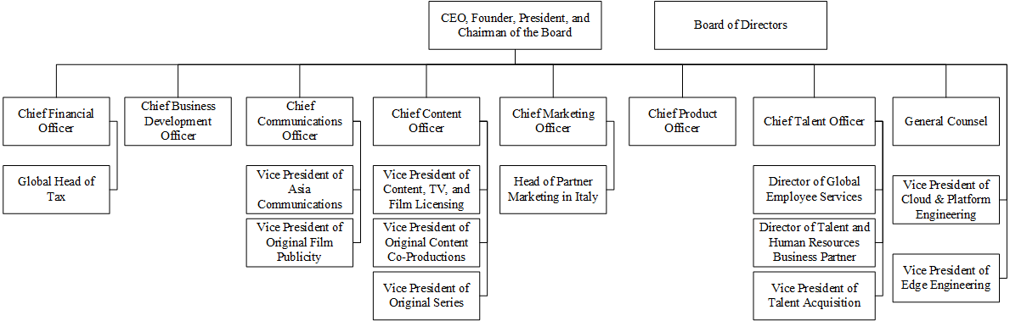
The current organizational chart has many executive reporting to the CEO of the company, who in turn has multiple titles and responsibilities. The current structure also uses inconsistent titles and divisions.

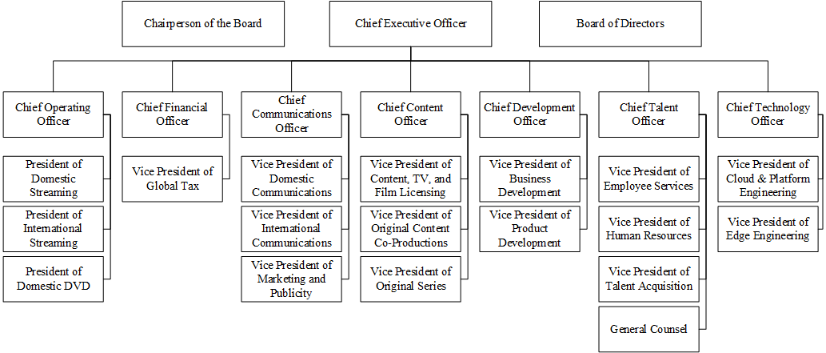
The revised organizational chart is designed with expansion in mind, adding a Chief Technology Officer, Chief Operating Officer, and division presidents. This allows for additional officers to be elected as Netflix elaborates on its international division and technological advances.

Perceptual Maps

For the perceptual maps, we will focus on Netflix’s original content series as it compares to original content series from other publishers. Netflix has identified that licensed content is not enough to distinguish itself among competitors, and so original content will be the focus for the perceptual maps.

Index | TV Show Name | Production Company | Production Cost (million) | Content Hours | Cost per Content Hour | IMDB Ratings
1 | Game of Thrones | HBO | $536 | 67 | $8.0 | 9.5
2 | House of Cards | Netflix | $240 | 52 | $4.6 | 9.0
3 | Daredevil | Netflix | $104 | 26 | $4.0 | 8.9
4 | Modern Family | ABC | $721 | 103 | $7.0 | 8.6
5 | Big Bang Theory | CBS | $1,004 | 126 | $8.0 | 8.5
6 | Sense 8 | Netflix | $216 | 24 | $9.0 | 8.4
7 | Orange is the New Black | Netflix | $245 | 65 | $3.8 | 8.4
8 | Once Upon a Time | ABC | $738 | 164 | $4.5 | 8.0
9 | Gotham | FX | $332 | 83 | $4.0 | 8.0
10 | Transparent | Amazon | $140 | 40 | $3.5 | 8.0

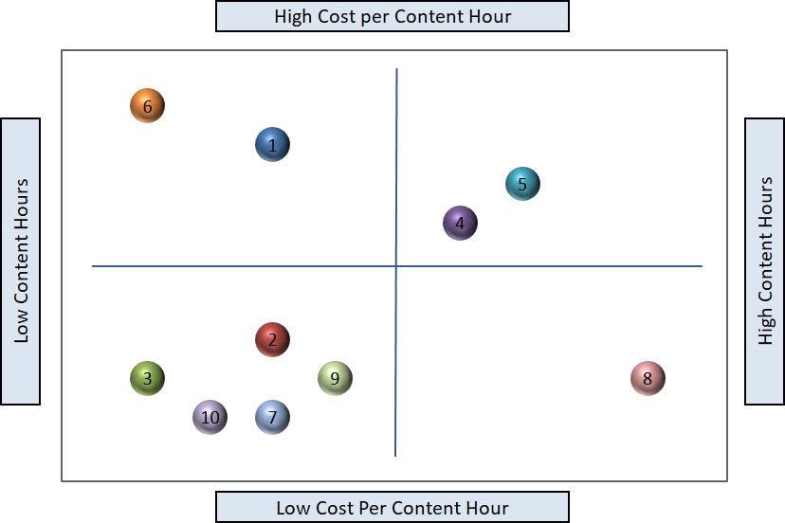
Comparing cost per content hour to number of content hours shows an abundance of shows with low cost per content hour and low content hours. Of these five shows, three belong to Netflix. This would seem to indicate that Netflix should prioritize another quadrant instead to distinguish itself. Considering Netflix has only recently begun creating original content, we can expect to see more shows shift rightwards as seasons are released. Thus, Netflix should naturally ease into its niche as popular shows increase in content hours and more expensive series are approved.
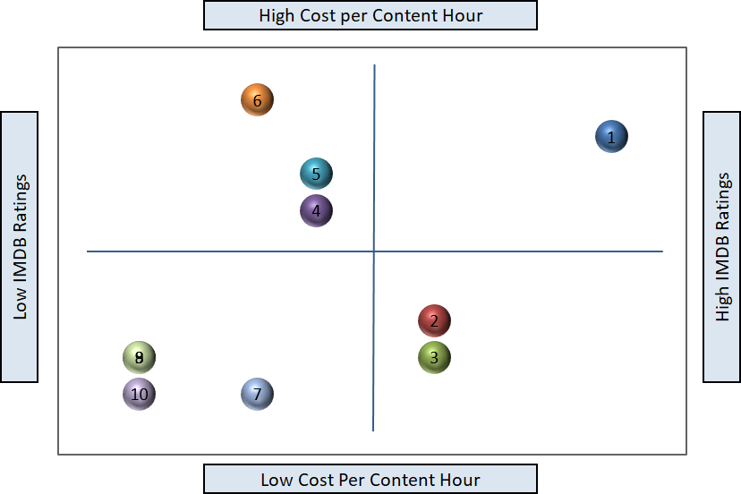
Besides HBO’s very successful Game of Thrones series, very few shows have high IMDB ratings and high cost per hour. The other two shows with above average IMDB ratings, both belonging to Netflix, have below average cost per content hour. Rather than overpopulating the quadrant, this is a quadrant dominated by Netflix and Netflix should prioritize content with low costs.
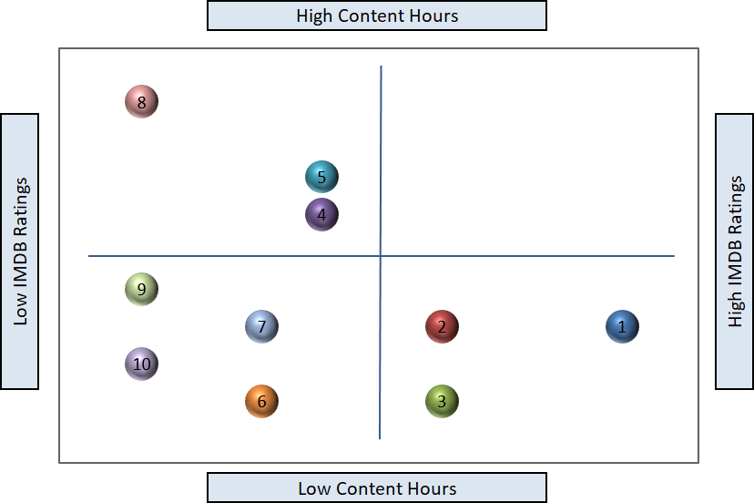
No shows that were reviewed had high content hours and high IMDB ratings. The top three shows all have less than average content hours, indicating that longer-run shows lose their appeal with time. This indicates that stories built around two to four seasons of content may perform better with audiences.

Firm Valuation

The valuation of Netflix using the average of the four methods below reveals that Netflix is in a comparable financial position relative to the more established Disney. Amazon, however, has been very successful with diversifying its service line and the average valuation listed below is a representation of those services.

Netflix
Stockholders' Equity - (Goodwill + Intangibles) | $3,581,956
Net Income * 5 | $2,794,645
(Share Price / EPS) x Net Income | $87,119,267
Number of Shares Outstanding x Share Price | $86,839,117
Method Average | $45,083,746

Amazon
Stockholders' Equity - (Goodwill + Intangibles) | $14,359,000
Net Income * 5 | $15,165,000
(Share Price / EPS) x Net Income | $570,611,919
Number of Shares Outstanding x Share Price | $570,724,800
Method Average | $292,715,180

Disney
Stockholders' Equity - (Goodwill + Intangibles) | $6,583,000
Net Income * 5 | $44,900,000
(Share Price / EPS) x Net Income | $175,211,867
Number of Shares Outstanding x Share Price | $175,302,400
Method Average | $100,499,317

Recommendations
 | Recommendations (costs in $ millions) | Year 1 | Year 2 | Year 3 | Total Cost
1 | Increase spending on content by $2 billion each year with a focus on producing original, binge-watching TV series | $10,000 | $12,000 | $14,000 | $36,000
2 | Increase spending on Technology and Development by 25% to stay current with technology trends | $1,325 | $1,650 | $2,050 | $5,025
3 | Increase spending on international marketing by 30% each year | $950 | $1,225 | $1,600 | $3,775
4 | Increase spending on domestic marketing by 40% next year in preparation of Disney's rival service, and 20% thereafter | $775 | $975 | $1,225 | $2,975
5 | Split International division into Asian, European, and Other, change Domestic to North American, and hire presidents and staff specific to each division | $400 | $250 | $300 | $950
6 | Commit to sourcing 80% or more of energy consumption to renewable sources by 2023 | $250 | $225 | $200 | $675
7 | Negotiate with Chinese government to offer jobs and resources within China to penetrate the market | $100 | $125 | $150 | $375
8 | Diversify services offered by investing in new streaming methods (such as 24/7 channels or mini-subscriptions) | $75 | $50 | $50 | $175
9 | Create student verification system and offer $1 domestic student discounts on lowest subscription package to target key demographic | $55 | $5 | $5 | $65
10 | Allocate resources to finding new artists that will produce original content exclusive to Netflix | $10 | $10 | $10 | $30
 | TOTALS | $13,940 | $16,515 | $19,590 | $50,045

Netflix’s three year aim will be to capitalize more heavily on its international presence while addressing the immediate issues of rival services entering the domestic market. Although a lot of attention is granted to the higher cost recommendations for attracting new members, many of the lower cost options are likely to increase retention with current members.

EPS-EBIT Analysis

Costs for the EPS-EBIT Analysis are listed in $ thousands except share data.
 | 100% Common Stock Financing |  |  |  | 100% Debt Financing
 | Recession | Normal | Boom |  | Recession | Normal | Boom
EBIT | 400,000 | 1,000,000 | 1,500,000 |  | 400,000 | 1,000,000 | 1,500,000
Interest | 0 | 0 | 0 |  | 250,225 | 250,225 | 250,225
EBT | 400,000 | 1,000,000 | 1,500,000 |  | 149,775 | 749,775 | 1,249,775
Taxes | 112,000 | 280,000 | 420,000 |  | 41,937 | 209,937 | 349,937
EAT | 288,000 | 720,000 | 1,080,000 |  | 107,838 | 539,838 | 899,838
# Shares | 459,463 | 459,463 | 459,463 |  | 433,383 | 433,393 | 433,393
EPS | $0.63 | $1.57 | $2.35 |  | $0.25 | $1.25 | $2.08

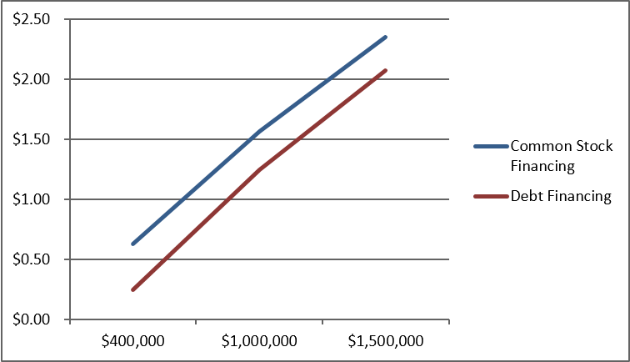

 | 50% Stock - 50% Debt |  |  |  | 20% Stock - 80% Debt
 | Recession | Normal | Boom |  | Recession | Normal | Boom
EBIT | 400,000 | 1,000,000 | 1,500,000 |  | 400,000 | 1,000,000 | 1,500,000
Interest | 125,113 | 125,113 | 125,113 |  | 200,180 | 200,180 | 200,180
EBT | 274,888 | 874,888 | 1,374,888 |  | 199,820 | 799,820 | 1,299,820
Taxes | 76,969 | 244,969 | 384,969 |  | 55,950 | 223,950 | 363,950
EAT | 197,919 | 629,919 | 989,919 |  | 143,870 | 575,870 | 935,870
# Shares | 446,428 | 446,428 | 446,428 |  | 438,607 | 438,607 | 438,607
EPS | $0.44 | $1.41 | $2.22 |  | $0.33 | $1.31 | $2.13

Netflix’s current capital structure consists of 19% stock and 81% debt. Graphically, we can see that equity financing will yield a higher EAT and EPS than debt financing. Ideally, 100% equity financing should be used to fund recommendations over the next three years. However, assuming Netflix does not wish to dilute its ownership drastically, a slower plan to increase equity financing over time is acceptable.

Projected Financial Statements

Projected income statement and balance sheet figures are provided in $ thousands.
Projected Income Statement | Current | 12/31/2018 | 12/31/2019 | 12/31/2020
Revenues | 11,693,000 | 15,551,000 | 20,839,000 | 28,132,000
Cost of Goods Sold | 7,660,000 | 10,264,000 | 13,754,000 | 18,567,000
Gross Profit | 4,033,000 | 5,287,000 | 7,085,000 | 9,565,000
Operating Expenses | 3,194,000 | 4,199,000 | 5,626,000 | 7,596,000
EBIT | 839,000 | 1,088,000 | 1,459,000 | 1,969,000
Interest Expense | 353,000 | 368,000 | 378,000 | 383,000
EBT | 486,000 | 720,000 | 1,081,000 | 1,586,000
Non-Recurring Events | 0 | 0 | 0 | 0
Tax | (74,000) | 72,000 | 109,000 | 161,000
Net Income | 560,000 | 648,000 | 972,000 | 1,425,000

Projected Balance Sheet | Current | 12/31/2018 | 12/31/2019 | 12/31/2020
Cash & Equivalents | 2,823,000 | 2,602,000 | 2,985,000 | 3,772,000
Accounts Receivable | 0 | 0 | 0 | 0
Inventory | 0 | 0 | 0 | 0
Other Current Assets | 4,847,000 | 5,347,000 | 5,847,000 | 6,347,000
Total Current Assets | 7,670,000 | 7,949,000 | 8,832,000 | 10,119,000
PPE | 319,000 | 449,000 | 479,000 | 509,000
Goodwill | 0 | 0 | 0 | 0
Intangibles | 0 | 0 | 0 | 0
Other Long-term Assets | 11,023,000 | 14,023,000 | 17,023,000 | 20,023,000
Total Long-Term Assets | 11,342,000 | 14,472,000 | 17,502,000 | 20,532,000
Total Assets | 19,012,000 | 22,421,000 | 26,334,000 | 30,651,000
Accounts Payable | 360,000 | 410,000 | 435,000 | 460,000
Other Current Liabilities | 5,107,000 | 5,507,000 | 5,907,000 | 6,307,000
Long-Term Debt | 6,499,000 | 6,999,000 | 7,499,000 | 7,999,000
Other Long-Term Liability | 3,465,000 | 3,765,000 | 4,015,000 | 4,215,000
Total Liabilities | 15,431,000 | 16,681,000 | 17,856,000 | 18,981,000
Common Stock | 1,871,000 | 1,882,00 | 1,897,000 | 1,912,000
Retained Earnings | 1,731,000 | 2,379,000 | 3,352,000 | 4,779,000
Treasury Stock | 0 | 0 | 0 | 0
Paid in Capital & Other | (21,000) | 1,479,000 | 3,229,000 | 4,979,000
Total Equity | 3,581,000 | 5,740,000 | 8,478,000 | 11,670,000
Total Liabilities & Equity | 19,012,000 | 22,421,000 | 26,334,000 | 30,651,000

Netflix finds itself in position to be aggressive and capitalize on its successes. Revenues and cost of goods sold are expected to increase steadily as we broaden our content library. Our net income is increasing steadily, although it may be disappointing from the 200% growth from 2016 to 2017. This is in part caused by the estimate used for taxes that have shifted unpredictably over the last three years. Rather, looking at the EBT may be a better indicator for Netflix’s growth without the uncertainty of taxes.

However, we must first establish a solid foundation for expansion going forward. Netflix will begin 2018 by changing its capital structure to rely more heavily on equity financing as supported by the EPS-EBIT Analysis. This is reflected by a 200% increase ($7 billion) in equity and a 23% increase ($3.5 billion) in liabilities over the next three years. Netflix will also push for international adoption by investing in foreign PPE for 2018. As a result of these changes, Netflix will see a small decrease in cash & equivalents used to build a foundation for expansion.

Projected Financial Ratios
 | Historical |  | Projected
 | 12/31/2016 | 12/31/2017 | 12/31/2018 | 12/31/2019 | 12/31/2020
Current / Quick Ratio | 1.247 | 1.403 | 1.343 | 1.393 | 1.495
Debt-to-Equity | 4.070 | 4.308 | 2.906 | 2.106 | 1.626
Times Interest Earned | 3.184 | 2.373 | 2.957 | 3.860 | 5.141
Asset Turnover | 0.650 | 0.615 | 0.694 | 0.791 | 0.918
Net Profit Margin | 0.021 | 0.048 | 0.042 | 0.047 | 0.051
Return on Assets | 0.014 | 0.029 | 0.029 | 0.037 | 0.046
Return on Equity | 0.070 | 0.156 | 0.113 | 0.115 | 0.122
Gross Profit Growth | 1.280 | 1.440 | 1.311 | 1.340 | 1.350
EBIT Growth | 1.242 | 2.208 | 1.297 | 1.341 | 1.350
Net Income Growth | 1.522 | 2.994 | 1.159 | 1.500 | 1.466

With an explosive 2017 fiscal year, many of the 2017 financial ratios are above-average compared to 2016 and earlier years. We can also expect some temporarily decreased ratios in 2018 to accommodate the foreign PPE and international expansion required for long-term survivability. More sustainable growth ratios can be found in 2019 and 2020 after Netflix has stabilized its foothold in foreign markets. Netflix will also experience a lowered debt-to-equity and increasing return on equity from shifting to higher equity financing. Lastly, asset turnover and return on assets are expected to increase with new additions to our content library.

Retained Earnings Table

Retained Earnings 2017 | $1,731,000
Net Income 2018 | $648,000
Retained Earnings 2018 | $2,379,000
Retained Earnings 2018 | $2,379,000
Net Income 2019 | $972,000
Retained Earnings 2019 | $3,352,000
Retained Earnings 2019 | $3,352,000
Net Income 2020 | $1,425,000
Retained Earnings 2020 | $4,779,000

Executive Summary

Netflix is the current leader for streaming video on demand services in America. With new competitors entering the market each year, Netflix establishes its competitive edge with original content and lack of advertisements. Investors have also found a home with Netflix, as Earnings per Share have tripled to an all-time high in the last year. After laying these foundations for domestic success, Netflix is now primed to target foreign markets and expand internationally. Recommendations for the next three years will focus on international expansion, increased content library, and service diversification.

International Expansion
The domestic market is limited in size, and global expansion is necessary for the success of Netflix. Dividing the ‘International’ segment into more appropriate ‘Europe,’ ‘Asia,’ and ‘Other’ divisions, assigning Presidents and staff to each new division, and increasing spending international marketing will allow for more direct strategies to be tailored for each region. Relabeling ‘Domestic’ to ‘North America’ will also include Canada and Mexico as key targets for marketing. We should also continue negotiations with the Chinese government as the last major country left to be penetrated by Netflix content.

Content Library
2017 marked a significant year for us as we spent $6 billion to expand our content library, of which $2 billion was spent on original content exclusive to Netflix. This trend will need to continue into the future as original programming provides us the crucial competitive edge against rival services. With Disney announcing a rival service for 2018 and subsequently pulling their content from our libraries, there will exist a gap for child- and family-friendly content in our library. However, our main focus should remain with ‘binge-worthy’ television content as the majority of our viewers spend upwards of five hours per week watching Netflix.

Service Diversification
Our current two biggest rivals, Amazon Video and Hulu, are backed by major companies with alternative streams of revenue. Netflix is not currently in position to purchase another company to expand our services, but this will be something to re-evaluate each year. Instead, we should leverage our current resources to diversify the way we provide content to our members. Providing 24/7 channels of streaming content to emulate a classic TV experience or offering mini-subscriptions for date nights are two examples of service diversification.

Following these key tactics, Netflix is projected to increase its international foothold while maintaining its established dominance in the domestic market. Shifting radically to an international focus will require significant upfront costs in 2018; however, the future looks highly lucrative for Netflix as we strive to become the best global distributor of streaming entertainment content.

