

**STARBUCKS**

A PROPOSED STRATEGIC PLAN FOR STARBUCKS

STOCK SYMBOL: SBUX

Ashley Locklair

Adam Martin

Amanda Kate VanSickle

Table of Contents

Introduction 3

Current Vision Statement 3

Current Mission Statement 4

Revised Vision Statement 4

Revised Mission Statement 4

Coffee Industry Overview 4

Competitor Overview 7

Competitive Profile Matrix (CPM) 8

Current Financial Position 8

Ratio Analysis 10

External Factor Evaluation (EFE) Matrix 12

Internal Factor Evaluation (IFE) Matrix 14

SWOT Matrix 16

Proposed Strategies developed from the SWOT Matrix 18

Strategic Position and Action Evaluation (SPACE) Matrix 20

The Boston Consulting Group (BCG) Matrix 21

Internal-External (IE) Matrix 22

The Grand Strategy Matrix 23

Quantitative Strategic Planning (QSPM) Matrix 24

Perceptual Map: Quality and Price 28

Perceptual Map: Geographical Availability and Products 29

Company Valuations: Starbucks vs Dunkin’ Donuts vs McDonalds 30

Original Organizational Chart 31

Revised Organizational Chart 32

Recommendations 33

EPS/EBIT Analysis: Tables and Graphs 34

EPS/EBIT Analysis: Explanation 35

Income Statement and Balance Sheet for 2015 and 2016 36

Projected Income Statement and Balance Sheet 37

Statement of Projected Retained Earnings 39

Executive Summary 40

**Introduction Narrative**

Good afternoon ladies and gentlemen, taken together we represent Starbucks’ strategic management team. My name Amanda VanSickle, I am an accounting major, and this is Ashley Locklair and Adam Martin, both marketing majors. Starbucks is the premier roaster, marketer and retailer of specialty coffee in the world, operating in more than 75 countries. Growing from a single coffee shop to over 24,000 retail stores, it is uncommon to travel a few roads without seeing the twin-tailed siren logo. Starbucks’ common stock trades on the NASDAQ Global Select Market under the symbol “SBUX.” Not only does the company offer what is considered the highest quality coffee, but it also provides customers with the “Starbucks Experience,” offering excellent customer service, clean stores, and a comfortable setting. Currently, Starbucks puts a lot of their resources into the Americas operating segment, specifically the United States. With the United States generating 69% of total revenues, there is a high risk to the business if the United States economy begins to slow. Starbucks needs to take precautionary measures by continually expanding into other countries while diversifying their business. Additionally, marketing promotion and the rewards program needs to be significantly updated, but we will get explain those concerns later in the presentation.

# Introduction

**Starbucks**

Operating in more than 75 countries, Starbucks is the world lead retailer of specialty coffee. Growing from one single coffee shop in Seattle, Washington in 1971, to over 24,000 retail stores around the world, Starbucks has grown into a nationwide brand. The name Starbucks comes from the first mate in Herman Melville’s *Moby Dick.* This also inspired the design of the logo featuring a twin-tailed siren from Greek mythology. Starbucks Corporation’s common stock trades on the NASDAQ Global Select Market ("NASDAQ") under the symbol "SBUX."

Starbucks is not only a place to purchase the most exemplary tasting coffee and tasty treats, but also serves as a meeting place to chat with friends, meet up, and even complete work. The music selected to play in the stores is chosen for the artsy appeal that coincides with the relaxed look and feel of the coffeehouse. The goal of Starbucks is to maintain our positive name in the way we engage with our customers and communities to continue to complete daily, successful business responsibilities.

Starbucks offers more than just coffee; we also offer all other items associated with a full coffeehouse experience. Products from premium teas and fine pastries to other sweets all individuals enjoy. Starbucks sells a variety of coffee and tea products and license their trademarks through licensed stores, grocery stores and foodservice accounts. Brands that are associated with Starbucks are Teavana, Tazo, Seattle’s Best Coffee, Evolution Fresh, La Boulange and Ethos.

Starbucks is divided into 4 major operating segments:

1) Americas, including the United States, Canada and Latin America

2) China/Asia Pacific (CAP)

3) Europe, Middle East and Africa (EMEA)

4) Channel Development

The Americas segment is the most mature business. CAP and EMEA are still in the early stages of development and require more support compared to the Americas. The Channel Development segment includes a variety of beverages and other branded products sold throughout the world through channels such as grocery stores, warehouse clubs, specialty retailers, convenience stores and foodservice accounts.

**Vision and Mission Statement Narrative**

The current **vision statement** for Starbucks indirectly segregates consumers through the use of the word “purveyor.” Starbucks needs to be respectful that their consumers come from many backgrounds and it is not necessary to add in a larger word to sound more sophisticated when simpler words will read better and not make their consumer pull out a dictionary, or worse, lose interest. We recommend changing the vision statement to use clear, simple language while showing a business long-term goal and to also include the customers, employees, and shareholders as an important long-term goal. The current **mission statement** is broad and leaves room for different interpretations. Although catchy, the mission statement is vague in regards to the nine mission statement components. Although one may be able to assume that Starbucks is speaking about their customers (1) and markets (3) by saying “one person” and “one neighborhood at a time,” we recommend that the mission statement be revised to be direct, concise, and target all nine of the mission statement components in order to show a customer perspective. The new mission statement shows Starbucks’ competitive advantage over rivals by detailing the highest of quality coffee and ableness to provide innovative and exciting products while promoting positivity and encouragement to the human spirit.

# Current Vision Statement

“To establish Starbucks as the premier purveyor of the finest coffee in the world while maintaining uncompromising principles while we grow.”

# Current Mission Statement

“To inspire and nurture the human spirit – one person, one cup and one neighborhood at a time.”

# Revised Vision Statement

“To become the world leader in the coffee industry, while continually exploring new cultural and geographical boundaries, and providing our customers, employees, and shareholders with the utmost respect and attention.”

# Revised Mission Statement

The primary goal of Starbucks is to inspire and nurture the human spirit. (1, 9) We seek to internationally provide the highest quality coffee, while continually striving to improve our products through innovative and exciting ways. (2, 3, 4) We are not only committed to our diverse customers and invaluable employees, but also to growing our environmental goals to reduce our environmental footprint. (1, 6, 7, 8, 9) Starbucks strives to steadily increase growth and profitability by creating new product offers and extending focus on the Starbucks brands in grocery stores. (5) We will make the world a happier place – one person, one cup, and one neighborhood at a time. (1, 7, 9)

1. Customers (6) Philosophy
2. Products or services (7) Self-Concept
3. Markets (8) Public Image
4. Technology (9) Employees
5. Survival, growth and profitability

# Coffee Industry Overview

Coffee is the most commonly consumed beverage worldwide and is continually growing, producing a demand that café owners and coffee exporters are eager to supply. The market is segmented into growers, roasters, and retailers. On the coffee-growing level, South America was ranked as the major coffee-producing region. Brazil produced and exported 43.2 million 60 kg bags of coffee in 2016. Other major producers are Vietnam and Columbia. Importing countries tend to consume less coffee than their importing counterparts.

The United States had the largest sales share with 45.8% of retail sales in 2016, followed by single-cup coffee. Coffee chains have become more and more popular among customers who enjoy their coffee to go. Starbucks and Dunkin Donuts dominated this out-of-home retail market, with a combined market share of over 65%. Growth in coffee cup per capita consumption is up 18% in China, 13% in the United Kingdom, and 3.5% in Japan.

Consumers drink on average 1.64 cups of coffee per day, reporting that they drink it at home, on the way to work, and at work, in order to wake up in the morning or receive a burst of energy throughout the day. Additionally, consumers in the United States tend to drink more coffee as they get older.

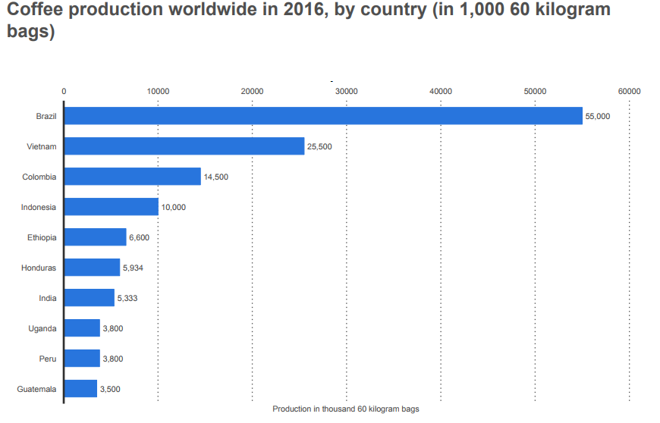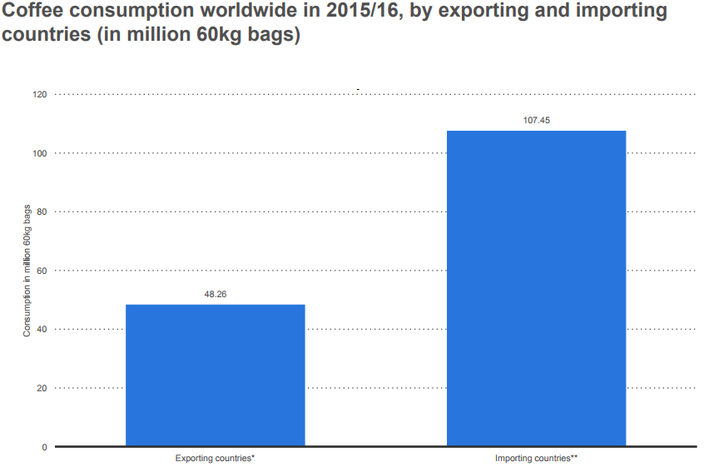Coffee consumption worldwide continues to increase from 146.98 million 60kg bags consumed in 2012 and 2013 to 155.71 million 60 kg bags consumed in 2015 and 2016.

Production in thousand 60 kg bags

Importing countries

Exporting countries

Consumption in million 60 kg bags

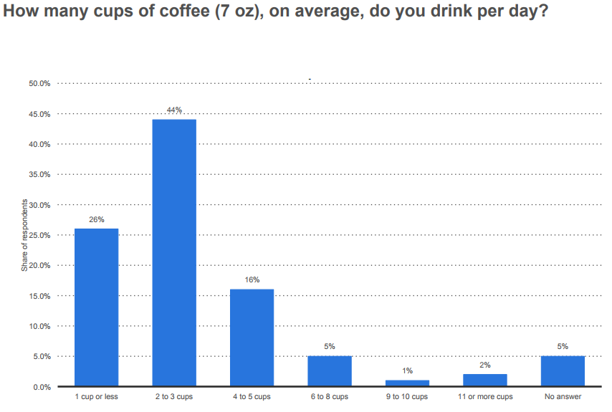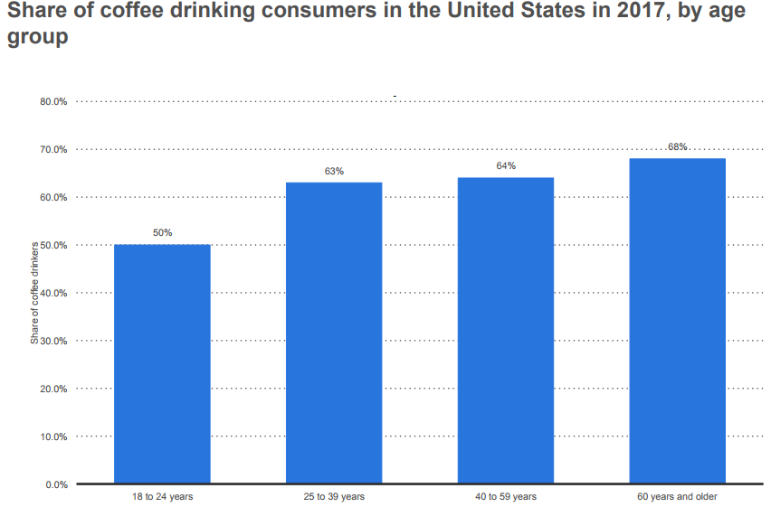

Share of respondents

Share of coffee drinkers

60 years +

40 to 59 years

25 to 39 years

18 to 24 years

# Competitor Overview

**Competition**

Our primary competitors for coffee beverage sales are specialty coffee shops and quick-service restaurants. In almost all markets in which we do business, there are numerous competitors in the specialty coffee beverage business. We continue to experience direct competition from large competitors in the U.S. quick-service restaurant sector and the U.S. ready-to-drink coffee beverage market, in addition to well-established companies in many international markets. We also compete with restaurants and other specialty retailers for prime retail locations.

**Dunkin’ Donuts**

In 1940, Bill Rosenberg founded his first restaurant and was subsequently renamed Dunkin’ Donuts. Serving as one of the world leading franchisors of quick service restaurants (QSRs), Dunkin’ Donuts has more than 20,000 points of distribution in more than 60 countries. Hot and cold coffee, baked goods, breakfast sandwiches and hard serve ice creams are products the company offers. Over the last 10 fiscal years, Dunkin’ Donuts have grown at a 6.1% compound annual growth rate. Total sales of $8.2 billion accounted for 76% of global system wide sales in 2016.

**McDonalds**

Originally known as McDonalds Bar-B-Q restaurant in 1940, the restaurant was open for 8 years before it was closed. Ray Kroc reopened McDonalds in 1955. The golden arches were designed by architect Stanley Meston and have become one of the most well-known restaurant symbols in the world. The company quickly spread throughout the United States with over 700 other operating McDonald’s restaurants. The first stock offering began at $22.50 per share for the 10th anniversary in 1965 and became an international restaurant. As of 2016, there are 15,065 McDonald’s restaurants in North America with 14,146 of them in the United States. There are more than 36,000 establishments across the globe that includes 420,000 employees.

# Competitive Profile Matrix (CPM)

|  |  |  |  |  |  |  |  |
| --- | --- | --- | --- | --- | --- | --- | --- |
|  |  | **Starbucks** | | **Dunkin' Donuts** | | **McDonalds** | |
| **Critical Success Factors** | **Weight** | **Rating** | **Score** | **Rating** | **Score** | **Rating** | **Score** |
| Product Quality | 0.15 | 4 | 0.60 | 3 | 0.45 | 2 | 0.30 |
| Increasing Market Share | 0.14 | 4 | 0.56 | 2 | 0.28 | 3 | 0.42 |
| Customer Loyalty | 0.13 | 4 | 0.52 | 2 | 0.26 | 3 | 0.39 |
| Financial Position | 0.10 | 3 | 0.30 | 2 | 0.20 | 4 | 0.40 |
| Global Expansion | 0.10 | 3 | 0.30 | 1 | 0.10 | 4 | 0.40 |
| Customer Service | 0.10 | 4 | 0.40 | 3 | 0.30 | 1 | 0.10 |
| Advertising | 0.05 | 2 | 0.10 | 3 | 0.15 | 4 | 0.20 |
| Brand Recognition | 0.05 | 4 | 0.20 | 1 | 0.05 | 3 | 0.15 |
| Store Locations | 0.05 | 3 | 0.15 | 1 | 0.05 | 4 | 0.20 |
| Price Competitiveness | 0.05 | 2 | 0.10 | 3 | 0.15 | 4 | 0.20 |
| Product Variety | 0.05 | 4 | 0.20 | 2 | 0.10 | 3 | 0.15 |
| Social Responsibility | 0.03 | 3 | 0.09 | 2 | 0.06 | 4 | 0.12 |
| **Totals** | **1.00** |  | **3.52** |  | **2.15** |  | **3.03** |

# Current Financial Position

Starbucks remains highly competitive in their financial position in comparison to Dunkin’ Donuts and McDonalds (excluding McDonalds’ food sales). In fiscal 2016, Starbucks generated 21.3 billion dollars in revenue while Dunkin’ Donuts reported sales of 828.9 million dollars. Starbucks generates all of their revenue through company-operated stores, licensed stores, consumer packaged goods, and foodservice operations.

Starbucks operates more of their own stores, in comparison to the many franchised stores of Dunkin’ Donuts and McDonalds; because of this Starbucks has tighter margins and Dunkin’ Donuts has a lower capital expense burden than Starbucks. Revenues from Starbucks licensed stores accounted for 10% of total net revenues in fiscal 2016. Licensed stores generally have a lower gross margin and a higher operating margin than company-operated stores. Although Starbucks receives a reduced share of the total store revenues, it is offset by the reduction in the share of costs as these are primarily incurred by the licensee.

Coffee is purchased using a fixed-price and price-to-be-fixed purchase commitments, depending on market conditions, to secure an adequate supply of quality green coffee. Total green coffee purchase commitments as of October 2, 2016 were 1.1 billion dollars, with 466 million dollars under fixed-price contracts and 641 million dollars under price-to-be-fixed contracts.

Total net revenues increased 11% to $21.3 billion in fiscal 2016 compared to $19.2 billion in fiscal 2015. Global comparable store sales grew 5% driven by a 4% increase in average ticket and a 1% increase in the number of transactions. Consolidated operating income increased to $4.2 billion in fiscal 2016 compared to operating income of $3.6 billion in fiscal 2015. Operating margin was 19.6% in fiscal 2016 compared to 18.8% in fiscal 2015. Operating margin expansion in fiscal 2016 was primarily driven by sales leverage and lower commodity costs, partially offset by investments in employees. Earnings per share for fiscal 2016 increased to $1.90 from $1.82 in fiscal 2015. Cash flows from operations were $4.6 billion in fiscal 2016 compared to $3.7 billion in fiscal 2015. This change was primarily due to increased earnings and the timing of cash payments for income taxes. Capital expenditures in 2016 were $1.4 billion compared to $1.3 billion in 2015. Overall, $3.2 billion was returned to shareholders in fiscal 2016 through share repurchases and dividends.

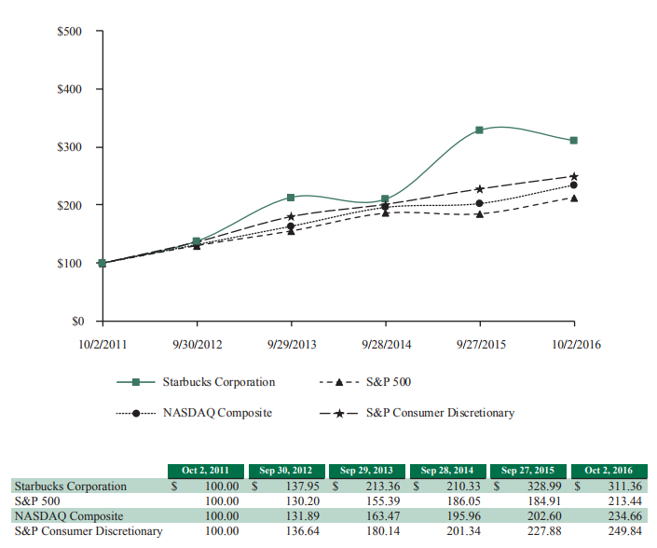The following graph depicts the total return to shareholders from October 2, 2011 through October 2, 2016, relative to the performance of the Standard & Poor’s 500 Index, the NASDAQ Composite Index and the Standard & Poor’s 500 Consumer Discretionary Sector, a peer group that includes Starbucks.

# Ratio Analysis

**Liquidity Ratio’s**

|  |  |  |  |  |  |
| --- | --- | --- | --- | --- | --- |
| **Quick Ratio** | **2016** | **2015** | **2014** | **2013** | **2012** |
| Starbucks | .67 | .64 | .81 | .71 | 1.14 |
| McDonalds | .78 | 3.04 | 1.2 | 1.3 | 1.09 |
| Dunkin Donuts | 1.03 | .91 | .86 | .96 | .84 |

|  |  |  |  |  |  |
| --- | --- | --- | --- | --- | --- |
| **Current Ratio** | **2016** | **2015** | **2014** | **2013** | **2012** |
| Starbucks | 1.05 | 1.19 | 1.37 | 1.02 | 1.9 |
| McDonalds | 1.4 | 3.27 | 1.52 | 1.59 | 1.45 |
| Dunkin Donuts | 1.43 | 1.33 | 1.24 | 1.34 | 1.19 |

**Leverage Ratio**

|  |  |  |  |  |  |
| --- | --- | --- | --- | --- | --- |
| **D/E Ratio** | **2016** | **2015** | **2014** | **2013** | **2012** |
| Starbucks | .61 | .40 | .39 | .29 | .11 |
| McDonalds | 0 | 3.4 | 1.17 | .88 | .89 |
| Dunkin Donuts | 0 | 0 | 4.93 | 4.48 | 5.28 |

**Activity Ratio’s**

|  |  |  |  |  |  |
| --- | --- | --- | --- | --- | --- |
| **Inv. Turnover** | **2016** | **2015** | **2014** | **2013** | **2012** |
| Starbucks | 6.34 | 6.5 | 6.23 | 5.43 | 5.27 |
| McDonalds | 159.73 | 133.05 | 130.84 | 126.96 | 127.66 |
| Dunkin Donuts | 5.28 | 5.04 | 4.97 | 4.88 | 4.57 |

|  |  |  |  |  |  |
| --- | --- | --- | --- | --- | --- |
| **Asset Turnover** | **2016** | **2015** | **2014** | **2013** | **2012** |
| Starbucks | 1.57 | 1.66 | 1.48 | 1.51 | 1.71 |
| McDonalds | .71 | .70 | .77 | .78 | .80 |
| Dunkin Donuts | .25 | .26 | .23 | .22 | .20 |

**Probability Ratio’s**

|  |  |  |  |  |  |
| --- | --- | --- | --- | --- | --- |
| **ROA** | **2016** | **2015** | **2014** | **2013** | **2012** |
| Starbucks | 20.71 | 23.84 | 18.62 | .08 | 17.81 |
| McDonalds | 13.55 | 12.34 | 13.42 | 15.51 | 15.94 |
| Dunkin Donuts | 5.99 | 3.31 | 5.52 | 4.57 | 3.37 |

|  |  |  |  |  |  |
| --- | --- | --- | --- | --- | --- |
| **ROE** | **2016** | **2015** | **2014** | **2013** | **2012** |
| Starbucks | 47.38 | 49.86 | 42.53 | .17 | 29.23 |
| McDonalds | 191.4 | 45.43 | 32.92 | 35.69 | 36.72 |
| Dunkin Donuts | 0 | 143.55 | 45.62 | 39.07 | 19.88 |

**Ratio Analysis**

|  |  |  |  |  |  |
| --- | --- | --- | --- | --- | --- |
| **ROI** | **2016** | **2015** | **2014** | **2013** | **2012** |
| Starbucks | 42.96 | 43.4 | 43.06 | (10.11) | 33.83 |
| McDonalds | 26.88 | 24.2 | 26.98 | 28.74 | 29.69 |
| Dunkin Donuts | 17.48 | 16.4 | 14.68 | 12.93 | 9.84 |

|  |  |  |  |  |  |
| --- | --- | --- | --- | --- | --- |
| **Net Margin %** | **2016** | **2015** | **2014** | **2013** | **2012** |
| Starbucks | 13.22% | 14.39% | 12.57% | 0.06% | 10.40% |
| McDonalds | 4.45% | 17.64% | 4.19% | 5.13% | 4.29% |
| Dunkin Donuts | 23.59% | 12.98% | 23.55% | 20.58% | 16.46% |

**External Assessment Narrative**

First, we will touch on the **opportunities** that lead to our recommendations over the next three years. Global economic growth is expected to rise from 2.4% in 2016, to 2.7% in 2016, and 2.9% in 2018. This leads to the recommendation of increasing expansion by 250 stores in China, Canada, and India, while eliminating additional United States expansion because these countries will have an increase in the capacity of goods and services. Ultimately, the economy will produce more than in previous years. Although the American market is mature, it becomes increasingly saturated, causing cannibalization in some of the markets. By moving into China, Canada, and India, we are able to get into an untapped market in comparison with consumers who have a large disposable income. Opportunities that fit the recommendation to create a rewards program for the current United States stores that is valuable to both loyal customers and new customers include: 150 million Americans over 18 years of age drink coffee daily with 30 million drinking specialty coffee and disposable income will continually increase 2.9% per year from 2017 to 2022. A better rewards program will retain customers by setting an achievable level of rewards and it will also make consumers want to spend their money with Starbucks instead of competitors. Setting up a good rewards program is vital because consumers realize that with every dollar spent with another company, they are not accumulating points towards free goods. With disposable income increasing, our higher prices will be of less concern to consumers. Opportunities that lead to the recommendation of promoting the Starbucks brand within popular television shows and movies through product placement are the same as the previous recommendation. Targeting promotion through popular television shows of various age groups will not only help to retain our brand in the eyes of the 150 million Americans who drink coffee daily, but will also help to bring in more customers through brand recognition. Additionally, the disposable income increase will help generate more sales from the people who visit Starbucks because of our new promotion. Now, to speak briefly on the **threats** regarding each of our recommendations. The threats for the recommendation to expand more into China, Canada, and India include: of the more than 200 billion dollars of revenues generated in 2016, farmers only received 15 billion dollars, with the average age of farmers being 55, younger generations are straying away from farming due to the low profitability; and China’s market conditions contain 30% more regulations than the United States. With younger generations straying away from farming, the price of coffee beans will eventually rise as the older farmers begin to die out. This will be bad for Starbucks’ expansion into China, Canada, and India because it will be much more costly for them. This will ultimately raise the risk of business and potentially lose many consumers due to an even further price increase of Starbucks’ coffee goods. Since China has higher regulations, Starbucks will need to hire a costly legal team to make sure they avoid any activity that is considered harmful in China. The threat regarding promotion and advertising is a large cup of coffee at McDonalds costs an average of $1.49, while a large cup of coffee at Starbucks averages $2.55. This is a major threat because advertising will not change the price of our coffee, and consumers may still prefer the cheaper option.

# External Factor Evaluation (EFE) Matrix

**Key External Factors**

|  |  |  |  |  |
| --- | --- | --- | --- | --- |
|  | Opportunities | Weight | Rating | Weighted Score |
| 1 | 150 million Americans over 18 years of age drink coffee daily with 30 million drinking specialty coffee. | 0.15 | 4 | 0.6 |
| 2 | Disposable income will continually increase 2.9% per year from 2017 to 2022. | 0.10 | 4 | 0.4 |
| 3 | Global economic growth expected to rise from 2.4% in 2016, to 2.7% in 2017, and 2.9% in 2018. | 0.05 | 3 | 0.15 |
| 4 | 87% of millennials drink tea. | 0.05 | 4 | 0.2 |
| 5 | The United States is the 3rd largest importer of tea in the world, buying 288 million pounds. | 0.04 | 3 | 0.12 |
| 6 | Coffee had the largest sale share with 45.9% in 2016 followed by one single-cup coffee. | 0.04 | 4 | 0.16 |
| 7 | 59% of coffee cups consumed daily in 2017 are now classified as gourmet, compared to 42% in 2012. | 0.03 | 4 | 0.12 |
| 8 | Sales of packaged and ready-to-drink coffee was up to 10% at $13.5 billion in 2015, and estimated to be at $18 billion by 2020. | 0.02 | 2 | 0.04 |
| 9 | Americans drink 20% more herbal beverages in 2017 compared to 2014. | 0.01 | 2 | 0.02 |
| 10 | The United States Tea Association surpassed $10 billion dollars in 2016. | 0.01 | 3 | 0.03 |

|  |  |  |  |  |
| --- | --- | --- | --- | --- |
|  | Threats |  |  |  |
| 1 | The location that people drink their coffee is strongly correlated to age; people 65 years and older are 2/3 likely to drink coffee at home, while coffee drinkers under 35 years old are nearly 1/3 more likely to drink coffee from a café. | 0.10 | 2 | 0.20 |
| 2 | A large cup of coffee at McDonalds costs an average of $1.49, while a large cup of coffee at Starbucks costs an average of $2.55. | 0.07 | 1 | 0.07 |
| 3 | 40% of daily consumers are drinking coffee prepared at home, reflecting a continuing trend in behavior as lifestyles become increasingly more health conscious and mobile. | 0.06 | 3 | 0.18 |
| 4 | Of the more than $200 billion revenues generated in the coffee industry in 2016, farmers only received $15 billion. With the average age of coffee farmers being 55, younger generations are straying away from farming due to the low profitability. | 0.06 | 2 | 0.12 |
| 5 | 66% of consumers are concerned with limiting their caffeine intake but only 16% of consumers report hearing information about the health benefits of coffee, down from 23% in 2015. | 0.04 | 1 | 0.04 |
| 6 | The world price of coffee grew to an annualized rate of 2.0% from 2012 to 2017; it is estimated to rise an additional 1.2% annually for the next 5 years to 2022. | 0.03 | 3 | 0.09 |
| 7 | As the world price of coffee increases, per capita coffee consumption will steadily decrease from 9.54 pounds per person in 2017 to 8.88 pounds per person in 2022, as more consumers will choose to brew their coffee at home. | 0.03 | 2 | 0.06 |
| 8 | Dunkin Donuts offers self-serve kiosks in grocery stores, hospitals, airports, offices, and other locations with retail footprints. | 0.03 | 1 | 0.03 |
| 9 | The quality of coffee and coffee technology is growing with a trend of fully automated machinery increasing. | 0.03 | 3 | 0.09 |
| 10 | China's market conditions contain 30% more regulations than the United States. | 0.05 | 2 | 0.10 |
|  | **TOTAL** | **1.00** |  | **2.82** |

**Internal Factor Evaluation Narrative**

Now to speak for a bit on Starbucks’ strengths and weaknesses that lead most directly to our recommendations for the next three years. The most vital strength for Starbucks is shown through our operating income increasing from $3.601 billion in 2015 to $4.172 billion in 2016, and our total net revenues increasing 11% to $21.3 billion in 2016 compared to $19.2 billion in 2015. This allows for additional asset purchases, capital expenditures, and global expansion which you can see was a huge inspiration for the recommendations to expand in China, Canada, and India, to create a new rewards program in the United States, and to increase our marketing through advertising. Another strength that led us to our recommendations is the total return to shareholders is up 125.71% from $137.95 in September of 2012 to $311.36 in October of 2016. This shows that Starbucks’ overall performance over this time was steadily rising and allows for a good analysis on our historical performance and helps to judge the amount of risk we can take in the future. A major weakness of Starbucks is their dependency on the financial performance of the United States. Although Starbucks operates in over 75 countries, 69% of revenues are generated in the United States. We are hoping by eliminating United States expansion and focusing on expanding by 250 stores in China, Canada, and India, we will be able to increase revenues in other countries while maintaining high revenues in the United States. Although we find this expansion risky, we believe with proper marketing towards the markets in those areas, we will be successful. An example of what we mean by this is to avoid Americanizing these segments; in China we will focus on hiring managers who know the country’s ethics and customs. Additionally, by eliminating additional expansion in the United States, we will reduce the chance of cannibalization between stores that are close. The weakness that led to the recommendation of recreating the reward system was in the current system you get 2 stars per $1 dollar spent, but you don’t get a free drink or food item until 300 stars, costing the consumer about $150 dollars to get to that tier. Consumers would need to drink coffee daily for over 2 months in order to benefit; we see this as a problem because it lacks motivation. By lowering the cost of receiving a free product while also offering coupons, consumers are motivated to visit Starbucks more frequently and to remain loyal to us. An overall weakness to Starbucks is the fact that they have imitable products that can be produced and sold cheaper. Although Starbucks may be more expensive, marketing and advertising that focuses on our quality of brewing and care to detail that competitors lack should help alleviate consumer concerns and show the differences between us and competitors.

# Internal Factor Evaluation (IFE) Matrix

**Key Internal Factors**

|  |  |  |  |  |
| --- | --- | --- | --- | --- |
|  | Strengths | Weight | Rating | Weighted Score |
| 1 | Operating income increased from $3,601 million in fiscal year 2015 to $4,172 million in fiscal year 2016 and total net revenues increased 11% to $21.3 billion in fiscal 2016 compared to $19.2 billion in fiscal 2015, allowing for additional asset purchases, capital expenditures, and global expansion. | 0.10 | 4 | 0.40 |
| 2 | The total return to shareholders is up by 125.71% from $137.95 in Sept of 2012 to $311.36 in Oct of 2016. | 0.09 | 4 | 0.36 |
| 3 | Starbucks has a high brand equity with a loyal customer base, generating more revenue from brand recognition. | 0.09 | 4 | 0.36 |
| 4 | Starbucks leads the industry in innovation with beverages such as cold brew, nitro, and frozen blended coffee. | 0.06 | 4 | 0.24 |
| 5 | Starbucks ethically sources high-quality coffee while reducing their environmental impact and contributing positively to communities around the world resulting in benefits to all stakeholders. | 0.05 | 4 | 0.20 |
| 6 | Starbucks has 12,711 company-operated stores, 12,374 licensed stores, and employs approximately 254,000 people. | 0.05 | 4 | 0.20 |
| 7 | Employee morale is high and Starbucks holds good, long-term relationships with their employees. | 0.04 | 4 | 0.16 |
| 8 | Starbucks has a strong global business model, and makes disciplined investments in their business and employees. | 0.03 | 4 | 0.12 |
| 9 | There are over 1,000 stores that are Leadership in Energy and Environmental Design (LEED) certified in 20 different countries. | 0.02 | 3 | 0.06 |
| 10 | Starbucks reduced water consumption from company-operated stores by 26.5% in 2015. | 0.02 | 3 | 0.06 |
|  | **Weaknesses** |  |  |  | |
| 1 | Starbucks is highly dependent on the financial performance of the United States operating segment; Starbucks operates in more than 75 countries, but 69% of revenues are generated in the United States. | 0.10 | 1 | 0.10 | |
| 2 | Starbucks has imitable products that can be produced and sold cheaper. | 0.08 | 1 | 0.08 | |
| 3 | The Europe, Middle East, and Africa segment only contributed to 6% of revenue in 2015. | 0.07 | 1 | 0.07 | |
| 4 | Europe, Middle East, and Asia segment revenues declined 8% to $1.1 billion in fiscal 2016 compared to a year ago. | 0.04 | 1 | 0.04 | |
| 5 | Product pricing; one customer buying the smallest, cheapest specialty drink at $3 dollars a cup can expect to spend $780 dollars a year. | 0.04 | 2 | 0.08 | |
| 6 | Revenue decreased 6% from $1294.8 million in 2014 to $1217.7 million in 2015. | 0.04 | 2 | 0.08 | |
| 7 | Starbuck's reward system is lacking. You get 2 stars per $1 dollar spent, at 300 stars you get a free drink or food item, costing about $150 dollars to get there. | 0.03 | 2 | 0.06 | |
| 8 | 74% of sales were from beverages, 19% from food, 3% from packaged and single-serve coffees and teas, and 4% from coffee-making equipment. | 0.02 | 1 | 0.02 | |
| 9 | Lack of internal focus; more interested in expansion, even though the majority of income is from the Americas. | 0.02 | 2 | 0.04 | |
| 10 | More marketing and advertising needs to be given for the Teavana brand. | 0.01 | 2 | 0.02 | |
|  | **Total IFE Score** | **1.00** |  | **2.75** | |

# SWOT Matrix

|  |  |
| --- | --- |
|  | **Strengths** |
| 1 | Operating income increased from $3,601 million in fiscal year 2015 to $4,172 million in fiscal year 2016 and total net revenues increased 11% to $21.3 billion in fiscal 2016 compared to $19.2 billion in fiscal 2015, allowing for additional asset purchases, capital expenditures, and global expansion. |
| 2 | The total return to shareholders is up by 125.71% from $137.95 in Sept of 2012 to $311.36 in Oct of 2016. |
| 3 | Starbucks has a high brand equity with a loyal customer base, generating more revenue from brand recognition. |
| 4 | Starbucks leads the industry in innovation with beverages such as cold brew, nitro, and frozen blended coffee. |
| 5 | Starbucks ethically sources high-quality coffee while reducing their environmental impact and contributing positively to communities around the world resulting in benefits to all stakeholders. |
| 6 | Starbucks has 12,711 company-operated stores, 12,374 licensed stores, and employs approximately 254,000 people. |
| 7 | Employee morale is high and Starbucks holds good, long-term relationships with their employees. |
| 8 | Starbucks has a strong global business model, and makes disciplined investments in their business and employees. |
| 9 | There are over 1,000 stores that are Leadership in Energy and Environmental Design (LEED) certified in 20 different countries. This includes the use of recycled coffee grounds in tabletops; low emitting materials for adhesives, paints, coatings, and flooring; over 10% of materials extracted within 500 miles; and over 45% light power savings through the use of efficient LED fixtures. |
| 10 | Starbucks reduced water consumption from company-operated stores by 26.5% in 2015. |
|  | **Weaknesses** |
| 1 | Starbucks is highly dependent on the financial performance of the United States operating segment; Starbucks operates in more than 75 countries, but 69% of the revenues are generated in the United States. |
| 2 | Starbucks has imitable products that can be produced and sold cheaper. |
| 3 | The Europe, Middle East, and Africa segment only contributed to 6% of revenue in 2015. |
| 4 | Europe, Middle East, and Asia segment revenues declined 8% to $1.1 billion in fiscal 2016 compared to a year ago. |
| 5 | Product pricing; one customer buying the smallest, cheapest specialty drink at $3 a cup can expect to spend $780 a year. |
| 6 | Revenue decreased 6% from $1294.8 million in 2014 to $1217.7 million in 2015. |
| 7 | Starbuck’s reward system is lacking. You get 2 starts per $1 spent, at 300 stars you get a free drink or food item, costing about $150 to get there. |
| 8 | Starbucks has a strong global business model, and makes disciplined investments in their business and employees. |
| 9 | Lack of internal focus; more interested in expansion, even though the majority of income is from the Americas. |
| 10 | More marketing and advertising needs to be given for the Teavana brand. |

|  |  |
| --- | --- |
|  | **Opportunities** |
| 1 | 150 million Americans over 18 years of age drink coffee daily with 30 million drinking specialty coffee. |
| 2 | Disposable income will continually increase 2.9% per year from 2017 to 2022. |
| 3 | Global economic growth expected to rise from 2.4% in 2016, to 2.7% in 2017, and 2.9% in 2018. |
| 4 | 87% of millennials drink tea. |
| 5 | The United States is the 3rd largest importer of tea in the world, buying 288 million pounds. |
| 6 | Coffee had the largest sale share with 45.9% in 2016 followed by one single-cup coffee. |
| 7 | 59% of coffee cups consumed daily in 2017 are now classified as gourmet, compared to 4.2% in 2012. |
| 8 | Sales of packaged and ready-to-drink coffee was up to 10% at $13.5 billion in 2015, and estimated to be at $18 billion by 2020. |
| 9 | Americans drink 20% more herbal beverages in 2017 compared to 2014. |
| 10 | The United States Tea Association surpassed $10 billion in 2016. |

|  |  |
| --- | --- |
|  | **Threats** |
| 1 | The location that people drink their coffee is strongly correlated to age; people 65 years and older are 2/3 likely to drink coffee at home, while coffee drinkers under 35 years old are nearly 1/3 more likely to drink coffee from a café. |
| 2 | A large cup of coffee at McDonalds costs an average of $1.49, while a large cup of coffee at Starbucks costs an average of $2.55. |
| 3 | 40% of daily consumers are drinking coffee prepared at home, reflecting a continuing trend in behavior as lifestyles become increasingly more health conscious and mobile. |
| 4 | Of the more than $200 billion revenues generated in the coffee industry in 2016, farmers only received $15 billion. With the average age of coffee farmers being 55, younger generations are straying away from farming due to the low profitability. |
| 5 | 66% of consumers are concerned with limiting their caffeine intake but only 16% of consumers report hearing information about the health benefits of coffee, down from 23% in 2015. |
| 6 | The world price of coffee grew to an annualized rate of 2.0% from 2012 to 2017; it is estimated to rise an additional 1.2% annually for the next 5 years to 2022. |
| 7 | As the world price of coffee increases, per capita coffee consumption will steadily decrease from 9.54 pounds per person in 2017 to 8.88 pounds per person in 2022, as more consumers will choose to brew their coffee at home. |
| 8 | Dunkin Donuts offers self-serve kiosks in grocery stores, hospitals, airports, offices, and other locations with retail footprints. |
| 9 | The quality of coffee and coffee technology is growing with a trend of fully automated machinery increasing. |
| 10 | China's market conditions contain 30% more regulations than the United States. |

**Proposed Strategies Developed from the SWOT Matrix Narrative**

Based on our SWOT analysis/matrix, we were able to uncover strategies that helped us in discovering the best recommendations for the next three years. Firstly, we were going to recommend increasing premium pricing by 10% for our innovative products to signal high quality through high price, but thinking in the long-term we realize that coffee beans are getting pricier each year and this increase in price will gradually happen on that fact alone. Starbucks is the United States’ number one coffee seller and it is not only important to keep that standing, but to also expand more directly in areas that we believe we can penetrate quickly and efficiently. The Weakness/Opportunity strategy that made it to the recommendation page was to eliminate additional United States expansion to reduce saturation and the chance of cannibalization and use the increased capital to increase expansion by 150 stores in China, Canada, and India. With this expansion we need on point marketing and advertising that targets culture in these areas. The Weakness/Threat strategy that made it to the recommendation page was to create a rewards program in the United States that is valuable to both loyal customers and new customers in order to increase footprint in stores and dissuade customers from visiting competitor stores; we need to lower the point requirement for a free beverage from 125 points to 75 points and give a 10% discount every time customers reach 60 points. When thinking of which strategies to include on the recommendations page, we thought it was vital to not ignore a major segment. So while we are stopping expansion in the United States, we are also adding a rewards system and advertising to increase footprint in the abundancy of stores we already have.

# Proposed Strategies developed from the SWOT Matrix

|  |  |
| --- | --- |
|  | **SO Strategies** |
| 1 | Increase premium pricing by 10% for innovative products such as the Nitro Cold Brew; high price signals high quality. (S3, S4, O2, O3) |
| 2 | Make the Teavana brand the face of premium tea across the country, in the same way Starbucks became the premium coffee. (S3, S7, O4, O5, O10) |
| 3 | Enhance quality control by routinely checking machinery every 2 months and upgrading machinery every 3 years to ensure Starbucks stays the highest quality in the industry. (S2, S3, S4, S5, O2, O3) |

|  |  |
| --- | --- |
|  | **ST Strategies** |
| 1 | Begin pushing 30% more packaged coffee into grocery stores and start building loyalty in customers that brew in-home. (S3, T3) |
| 2 | Buy 100 kiosks in grocery stores in states that have the most Starbucks stores, such as Washington and Nevada, to continue to increase brand recognition and loyalty by serving customers in convenient locations. (S3, T3) |
| 3 | Increase farmer's income by 20% to motivate them to continue providing Starbucks with high quality coffee beans while reducing environmental impact. (S5, T4)) |

|  |  |
| --- | --- |
|  | **WO Strategies** |
| 1 | Eliminate additional United States expansion to reduce saturation and the chance of cannibalization and use the increased capital to increase expansion by 150 stores in China, Canada, and India. (W1, W3, O3) |
| 2  3 | Acquire patents for new innovative products and machines in order to keep competition from imitating them. (W2, W5, O7)  Double the food business over the next 3 years from 19% of sales to 39% of sales, providing breakfast and lunch meals along with "grab and go" snacks. (W8, O3) |

|  |  |
| --- | --- |
|  | **WT Strategies** |
| 1 | Create a rewards program that is valuable to both loyal customers and new customers in order to increase footprint in stores and dissuade customers from visiting competitor stores. Lower the point requirement for a free beverage from 125 points to 75 points and give a 10% discount every time customers reach 60 points. (W5, T2) |
| 2 | Eliminate the Europe market and concentrate expansion in China, Canada, and India by introducing 150 new stores in popular cities. (W1, W3, W4, T6, T10) |
| 3 | Upgrade coffee-making equipment every two years to account for more sales by using new and improved technology. (W8, T9) |

# Strategic Position and Action Evaluation (SPACE) Matrix



|  |  |  |
| --- | --- | --- |
|  | x-axis | y-axis |
| 1. Starbucks | 1.0 | 0.4 |
| 2. Dunkin’ Donuts | 0 | 2.0 |
| 3. McDonalds | 1.0 | -3.0 |



The SPACE Matrix has been used to help identify Starbucks overall strategic position. Competitors Dunkin Donuts and McDonalds are also represented for comparison. Starbuck’s position suggests it is less aggressive than Dunkin but leading McDonalds. Given their position, Starbucks should seek strategies that allow for market penetration in areas that Dunkin exceeds in such as kiosks in grocery stores.

**BCG Matrix Narrative**

Now, looking at the Boston Consulting Group Matrix, we wanted to make sure that with the future recommendations, we were going to be focusing on the right product divisions. Take notice of food being in quadrant one, indicating that the cash generation is low while the cost is high. Although Starbucks may make the incorporation of food into their business work eventually, we do not believe it should be a major concern at the moment. When looking at quadrant two, beverages are dominant here with packaged coffee doing well also, showing that they are Starbucks’ best long-run opportunities for growth and profitability. This lines up with our upcoming recommendations because we did not see it fit to spend a lot of resources on promoting and incorporating food while we are focusing on expansion and promotion of what people think of when they hear the name Starbucks, coffee.

# The Boston Consulting Group (BCG) Matrix



|  |  |  |  |  |
| --- | --- | --- | --- | --- |
| **Division** | **Revenues**  **($ in billions)** | **Top Firm Divisions Revenues** | **Growth Rate**  **(%)** | **RMSP** |
| Beverages and Teavana | 14,954,900 | 14,954,900 | 0.08 | 1.00 |
| Food | 3,495,000 | 12,760,000 | 0.10 | 0.24 |
| Packaged Coffee | 2,866,000 | 3,860,000 | 0.11 | 0.74 |

The analysis of Starbucks’ divisions can help drive the decision and determine the best plan of action regarding the strategy recommendations. Starbucks’ three main divisions include: beverages, food, and packaged coffee. Teavana is currently listed as “other” in the company’s 10-K. For this examination, Teavana’s revenue was included with the beverages revenue. Since Teavana is a newer brand with lower income, if it were held as its own division, it would look like it belonged in the “Dogs” quadrant, and that is not the case. Beverages, Teavana, and packaged coffee are located in Quadrant II, indicating that they are the company’s best long-run opportunities for growth and profitability. Food is located in Quadrant I and indicates that the cash generation is low while the cost is high.

# Internal-External (IE) Matrix

|  |  |  |  |
| --- | --- | --- | --- |
| **Geographical Divisions** | **Division Revenues (Billions)** | **Estimated IFE Score** | **Estimated EFE Score** |
| **Americas** | $14.80 | 3.2 | 3.5 |
| **China/Asia Pacific** | $2.94 | 1.5 | 2.0 |
| **EMEA** | $1.12 | 1.0 | 1.0 |

The Internal-External Matrix for geographical divisions currently shows that the Americas are the strongest region. The goal with the Americas division is to grow and build in the form of discovering new and innovative products for our current stores. We do not want to oversaturate the Americas segment and cause cannibalization among our stores that are becoming closer in proximity. The China/Asia Pacific and Europe, Middle East, and Africa segments show a sign of needing to reduce costs or remove business from these locations. However, in reference to strategies, we want to increase expansion in the China/Asia Pacific segment to make it more profitable. We believe with targeted marketing and market penetration, this segment will grow and be successful.

# The Grand Strategy Matrix

|  |  |  |
| --- | --- | --- |
|  | x-axis | y-axis |
| Americas | 9 | 7 |
| China/Asia Pacific | 8 | 4 |
| EMEA | 4 | 2 |

The Grand Strategy Matrix provides further direction to figuring out alternative strategies. This further solidifies the option to further expand in the China/Asia Pacific division. The Europe, Middle East, and Africa segment are again showing an overall weak position. With the Americas being in a highly stable and wealthy position, the strongest way for Starbucks to continue to grow is to focus on another segment (China/Asia Pacific).

# Quantitative Strategic Planning (QSPM) Matrix







# Perceptual Map: Quality and Price



Starbucks continues to lead the coffee industry in high quality products, while keeping to their high quality, high price marketing. Rising in high quality products are growing franchises such as The Human Bean and Scooter’s Coffee. These types of stores provide quality and price relative to Starbucks but fail to penetrate the market due to being localized stores and having low brand recognition. On the other end, stores such as McDonalds, Burger King, and Krispy Kreme have lower quality offerings with low prices.

# Perceptual Map: Geographical Availability and Products



Starbucks and McDonalds both have high geographical availability by being global and steadily expanding, however, Starbucks offers a wide variety of innovative products and McDonalds sticks with more standard, non-risky products. Franchised stores such as The Human Bean and Scooter’s Coffee offer more innovative products in comparison to stores such as Krispy Kreme and Dunkin’ Donuts, but do not have the geographical availability compared to other companies in the industry.

# Company Valuations: Starbucks vs Dunkin’ Donuts vs McDonalds

|  |  |
| --- | --- |
| **Starbucks** |  |
| Stockholders' Equity - (Goodwill + Intangibles) | $3,607,000,000 |
| Net Income x 5 | $11,963,500,000 |
| (Share Price/EPS) x Net Income | $80,020,938,000 |
| Number of Shares Outstanding x Share Price | $80,020,938,000 |
| **Method Average** | **$43,903,094,000** |

|  |  |
| --- | --- |
| **Dunkin' Donuts** |  |
| Stockholders' Equity - (Goodwill + Intangibles) | ($2,267,871,841) |
| Net Income x 5 | $908,930,000 |
| (Share Price/EPS) x Net Income | $6,657,460,795 |
| Number of Shares Outstanding x Share Price | $6,657,656,199 |
| **Method Average** | **$2,989,043,788** |

|  |  |
| --- | --- |
| **McDonalds** |  |
| Stockholders' Equity - (Goodwill + Intangibles) | ($11,298,700,000) |
| Net Income x 5 | $27,825,000,000 |
| (Share Price/EPS) x Net Income | $129,996,900,000 |
| Number of Shares Outstanding x Share Price | $129,996,900,000 |
| **Method Average** | **$69,130,025,000** |

# Original Organizational Chart

Chairman

Chief Executive Officer

Executive Vice President, General Counsel and Secretary

President and Chief Operating Officer

Executive Vice President, Chief Financial Officer

Group President, Siren Retail

Group President,

Starbucks Global Retail

The original organizational structure is very simple and only concerns the very top of management.

# Revised Organizational Chart

Board of Directors

Chairperson

Chief Executive Officer

Chief Legal Officer

Chief Operating Officer

Chief Financial Officer

Starbucks Global Retail

Siren Retail

Chief Strategy Officer

Chief Marketing Officer

Americas Marketing Manager

Americas Strategy Manager

President of

Americas

President of

China/Asia Pacific

President of

EMEA

China/Asia Pacific Strategy Manager

China/Asia Pacific Marketing Manager

U.S. Manager

U.K. Manager

China Manager

Austria Manager

Switzerland Manager

France Manager

EMEA Strategy Manager

EMEA Marketing Manager

Japan Manager

Canada Manager

Thailand Manager

Singapore Manager

Netherlands Manager

Germany Manager

To address the lack of attention to specific management, the revised organizational structure includes management in all segments by their continent. It is important for Starbucks to include managers that share the same cultural identities to effectively and efficiently manage the stores in their respective areas.

**Recommendations Narrative**

Our ten recommendations with costs are included in the table below. We chose three official recommendations out of these ten that we believe will give the best growth over the next three years. Most importantly, we recommend eliminating additional United States expansion to reduce saturation and the chance of cannibalization and to use the increased capital to increase expansion by 250 stores in China, Canada, and India. Each store costs $450,000 to build and get running, totaling $112,500,000 for all 250 stores; this is assuming that all of the new stores will be freshly built and not rented. We will be hiring managers for each segment, respectively, in order to avoid disrespecting cultures and ethics that are not present in American culture. Secondly, we would like to create a new rewards program for the United States stores that will be valuable to both loyal customers and new customers. This will increase footprint in stores while dissuading customers from visiting competitor stores. To do this we will lower the point requirement for a free beverage from 125 points to 75 points and give a 10% discount every time customers reach 60 points. There are 15,607 total United States stores that average 500 customers per day. At a rate of $1 per card, $400 per store for software needed, and $20 per month for software usage, the total to implement the revamped rewards system will total $21,479,760. For our third recommendation, we would like to carefully promote the Starbucks brand within the context of popular television shows and movies through product placement, making sure that we do not place our product within a scene that would be viewed as inappropriate and result in promoting a bad name for Starbucks. It costs $20,000 for a visual placement, $40,000 for a brand name mention, and $60,000 for an action to use the product in a scene. The total cost for this recommendation would be $250,000,000. We would like to create the rewards program in the first year, expand in all three years, and promote in all three years.

# Recommendations

|  |  |
| --- | --- |
| **Recommendation** | **Total Cost** |
| **Eliminate additional United States expansion to reduce saturation and the chance of cannibalization and use the increased capital to increase expansion by 250 stores in China, Canada, and India.** | 112,500,000 |
| **Create a rewards program for the United States stores that is valuable to both loyal customers and new customers. This will increase footprint in stores and dissuade customers from visiting competitor stores. We will lower the point requirement for a free beverage from 125 points to 75 points and give a 10% discount every time customers reach 60 points.** | 21,479,760 |
| Hire 25 graphic and web designers to extend digital engagement through social media, magazine advertising (including digital magazines), and through the Starbucks website. | 1,005,975 |
| Hire 10 marketing experts to extend advertising engagement through television, billboard, and direct mail. | 600,000 |
| **Carefully promote the Starbucks brand within the context of popular television shows and movies through product placement, making sure that we do not place our product within a scene that would be viewed as inappropriate and promote a bad name for Starbucks.** | 250,000,000 |
| Open a food factory center to help double food sales from 19% of sales to 39% of sales through making Starbucks a lunch destination, encouraging customers to attach food items to their beverage orders. (Includes salaries for 100 workers + Equipment) | 22,900,100 |
| Purchase 100 grocery store kiosks globally in pre-punctured markets to expand into competitor territories. | 12,800,000 |
| Launch a global promotion of Teavana Tea brand by establishing it as a premier, top of the line tea sold by Starbucks. | 1,200,000 |
| Divide the US into 48 regions and hire 6 maintenance crew workers for each region to maintain equipment bi-monthly and install new equipment every 3 years. | 67,788,000 |
| Expand into Europe by opening 60 stores on college campuses to increase the European segment revenues. | 21,000,000 |
| **Total cost of recommendations:**  **\*The bolded recommendations above are the recommendations chosen to carry out the three year strategic plan.** | **511,273,835** |

**\***Rewards program: 15,607 US stores averaging 500 customers per day. $1 per card, $400 dollars per store for software needed, $20 per month for software usage.

**\***Product placement: $20,000 for a visual placement, $40,000 for a brand name mention, $60,000 for an action to use the product in a scene.

**\***Distribution center: 680,000 square feet in Raleigh, NC at 104 dollars per square feet [www.buildingjournal.com/construction-estimating.html](http://www.buildingjournal.com/construction-estimating.html) + estimated costs for equipment.

**EPS-EBIT Analysis Narrative**

The EPS/EBIT analysis revealed a minuscule difference between financing through equity versus financing through debt. We looked towards the economy and kept our current shareholders in mind when choosing between debt and equity financing. We chose to finance through debt because interest rates are so low right now making financing through debt pretty cheap. Additionally, by financing through debt, Starbucks will be able to deduct the interest for taxes, making the cost of debt even lower. Financing through common stock would end up costing more in the long run because returns to equity are continually offered through perpetuity. We also did not want to dilute our current stockholder’s percentage ownership of Starbucks.

# EPS/EBIT Analysis: Tables and Graphs





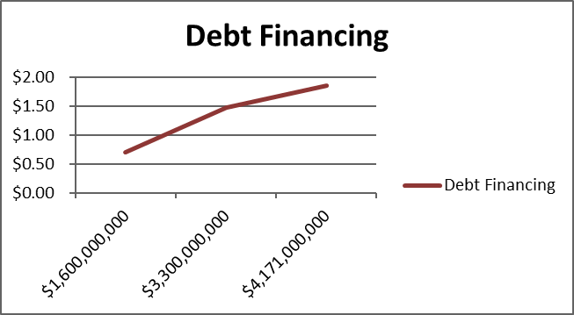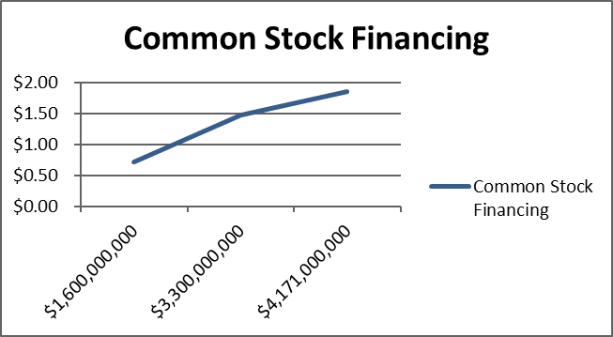

# 

# EPS/EBIT Analysis: Explanation

The EPS/EBIT analysis revealed a very minuscule difference between financing through equity versus financing through debt. The decision to finance through debt was derived from debt being very cheap right now because interest rates are low; Starbucks can also deduct the interest for taxes, making the cost of debt even lower. Since we are increasing production, it will lead to increased revenues, which will then lead to an increased return on assets. Additionally, long-term debt eventually expires through maturity dates and is highly structured, while equity financing would be more expensive over time because Starbucks would have to continue to offer returns to equity in perpetuity. The main reason stock financing was not considered further was because we wanted to avoid diluting our current stockholders’ percentage ownership of Starbucks. The cost of equity is the required return on Starbucks’ stock, which is much higher than the cost of debt.

# Income Statement and Balance Sheet for 2015 and 2016

**Projected Income Statement Narrative**

The projected income statement shows revenues steadily increasing as we implement our new stores in China, Canada, and India and increase footprint in our United States stores through the new rewards program and television/movie promotions. The cost of goods sold will go up due to continually increasing prices of coffee beans and it will go up more from 2016 to 2017 because that is the timeline of when our new rewards program cards will be purchased and implemented. Our net income will steadily rise at a slow rate over the first three years due to business startups in new countries taking time to implement and grow a loyal customer base. Administrative expenses that are included in operating expenses will grow significantly due to the 250 new stores and new management being hired in the segments. Interest expense from our bonds is calculated by taking the total of years one, two, and three and multiplying it by an interest rate of 6%, $160,612,760 x .06 = $9,636,756; $111,350,000 x .06 = $6,681,000; $111,350,000 x .06 = $6,681,000.

**Projected Balance Sheet Analysis Narrative**

The accounts that are going to be affected the most in our balance sheet is going to be our long-term debt, property plant and equipment, and inventory. Since we are financing through debt, long-term debt will go up each year. In year one $167,483,000 will be added to long-term debt, with 42 stores in China, 21 stores in Canada, and 20 stores in India being implemented for $55,800,000; the rewards program being implemented in 2017 for $28,350,000; and promotion being purchased for $83,333,000. In year two $111,683,000 will be added to long-term debt, with 22 stores in China, 20 stores in Canada, and 20 stores in India being implemented for $28,350,000 and promotion being purchased for $83,333,000. Year three will follow the same format as year two with an increase of $28,350,000 to long-term debt. Property, plant, and equipment will increase from the new stores and inventory will increase from resources needed in each of the stores and from the new rewards program cards. Net earnings were transferred to the balance sheet in year one (2017) by taking the retained earnings in 2016 of $5,949,800,000 and adding in the net income from 2017 of $2,476,765,346, and then subtracting out the dividends paid in 2017 of $1,200,000,000, equaling the retained earnings shown on the balance sheet for 2017 of $7,226,565,346. This same format was used for years 2018 and 2019.

# Projected Income Statement and Balance Sheet

*Details are provided on the following page.

**Details Regarding Projected Financial Statements**

1. Starbucks needs to raise 383,979,760 dollars in order to finance recommendations one, two, and five.

2. 100% of this will be raised through increased debt.

3. Cost of goods sold will go up due to continually increasing prices of coffee beans.

4. The promotion of Starbucks in movies and television shows will be 83,333,000 million dollars per year.

5. New stores for year one: forty-two stores in China, twenty-one stores in Canada, and twenty- stores in India equaling 55,800,000.

6. New stores for year two: twenty- stores in China, twenty- stores in Canada and, twenty- stores in India equaling 28,350,000.

7. New stores for year three: twenty- stores in China, twenty- stores in Canada and, twenty-stores in India equaling 28,350,000.

8. The rewards program will all be incorporated in 2017 for 21,479,760.

9. Interest on first year loan = 160,612,760 x .06 = 9,636,756

10. Interest on second year loan = 111,350,000 x .06 = 6,681,000

11. Interest on third year loan = 111,350,000 x .06 = 6,681,000

* We choose to finance through debt and not issue common stock because we do not want to dilute the ownership of existing shareholders.
* Dividends are 1.2 billion for years one and two and 1.25 billion for year three

# Statement of Projected Retained Earnings

|  |  |
| --- | --- |
| Statement of Projected Retained Earnings | |
| Retained Earnings 2016 | $5,949,800,000 |
| Net Income 2017 | $2,476,765,346 |
| Total | **$8,426,565,346** |
| Less Dividends Paid 2017 | ($1,200,000,000) |
| Retained Earnings 2017 | **$7,226,565,346** |
|  |  |
| Retained Earnings 2017 | $7,226,565,346 |
| Net Income 2018 | $2,561,993,569 |
| Total | **$9,788,558,915** |
| Less Dividends Paid 2018 | ($1,200,000,000) |
| Retained Earnings 2018 | **$8,588,558,914** |
|  |  |
| Retained Earnings 2017 | $8,588,558,914 |
| Net Income 2019 | $2,639,768,688 |
| Total | **$11,228,327,602** |
| Less Dividends Paid 2019 | ($1,250,000,000) |
| Retained Earnings 2019 | **$9,978,327,602** |

**Conclusion Narrative**

Starbucks continues to lead the way in the specialty coffee business. While costs remain higher due to ongoing expansion, we still look forward to good earnings gains in the coming quarters. In conclusion, we are recommending strategies that will reduce future risk while continually growing and allowing us to remain the biggest coffee shop brand in America and globally. We expect these recommendations to increase stability while improving profits in oversea countries. Thank you.

# Executive Summary

Starbucks is the largest coffee shop brand in America and globally. They strive to fulfill their mission statement each day; “to inspire and nurture the human spirit – one person, one cup, and one neighborhood at a time.” The key to establishing a strong hold within the coffee industry is by creating high quality and innovative products, while maintaining excellent customer service. In the past three years, Starbucks has established themselves with investor’s by making a conscious effort to double their food sales. This resulted in increased investor relations and created a less fluctuant stock price within the industry.

Recommendations over the next three years are concentrated on a few main objectives: to increase expansion in China, Canada, and India, to increase marketing strategies through advertising, and to establish a rewards system within the United States.

**Global Expansion**   
Global Expansion will be vital to the enhancement of Starbucks throughout the following years. We will do this by eliminating additional United States expansion to avoid cannibalization and increase expansion by introducing 84 stores in China, 63 stores in Canada, and 63 stores in India. Global expansion is key because there are overseas markets that have not been completely penetrated by the brand and this will increase awareness and sales.

**Marketing**

Advertising will be increased by carefully promoting the Starbucks brand within the context of popular television shows and movies through product placement, making sure that we do not place our products within a scene that would be viewed as inappropriate and promote a bad name for Starbucks. By implementing this tactic, brand recognition will increase and our logo will be fresh in the consumer’s mind.

**Rewards System**

The rewards system will serve to be valuable to both loyal customers and new customers, resulting in increased footprint throughout United States stores. This will dissuade customers from visiting competitor stores. Overall, the current rewards program will be redesigned by lowering the point requirement for a free beverage from 125 points to 75 points and give a 10% discount every time customers reach 60 points. The revamped rewards system will create an incentive for Starbucks’ customers and give them more reason to buy from us instead of competitors.

The projected statements show that over the next three years, Starbucks will continue to increase their revenues and grow. Dividend will continually be paid over these three years in order to keep shareholder loyalty.

By implementing these key tactics Starbucks will look to increase its stronghold on the coffee industry as it continues for the next three years. Not only will the United States markets increase and remain stable, but Starbucks will look to do the same in the global markets as they expand.